Capgemini response to SOK IT tender for integration (EAI) services

Prepared for: SOK IT Infrastructure

By Pentti Rosendahl

Address: Niittymäentie 9, 02200 ESPOO

Telephone: 0400 405 620

Email: pentti.rosendahl@capgemini.com

Date of Proposal: 30.9.2014

**NOTICE TO THE RECIPIENT OF THIS PROPOSAL**

The information contained herein is the proprietary and confidential information of Capgemini, and its unauthorized disclosure or release would offer substantial benefit to competitors offering similar services. This material includes descriptions of methodologies and concepts derived through substantial research and development efforts undertaken by Capgemini. Therefore, the use or release of the information contained in this proposal for purposes other than for the evaluation of its contents as a basis for contract award is strictly prohibited unless required by law.

This proposal must not be reproduced (in whole or in part) by any means or transmitted without the prior written permission of Capgemini, except with respect to copies made or transmitted internally by you for the purpose of evaluating this proposal. All copies of this proposal (or any portion hereof) and any accompanying electronic copies should be returned to Capgemini or, at Capgemini’s option, destroyed at the end of the proposal evaluation period if Capgemini is not selected.

This bid is valid for a period of **nine (9) calendar months** following the submission date Sep 30, 2014.

The term "Capgemini" appearing in this proposal may refer to Capgemini Finland Oy, or to one or more of its global affiliates; however, this proposal is being submitted by only Capgemini Finland Oy, which is solely responsible for its contents and Capgemini Finland Oy shall be the contracting entity if its proposal is selected.

Table of Contents

1 Summary of Quotation 5

2 Capgemini Introduction 7

2.1 Ownership Structure 7

2.2 Revenues per Business line 7

2.3 Industry, Core Competencies, Relevant Areas of Expertise 8

2.3.1 Capgemini Infrastructure Service Offering 9

2.3.2 Capgemini Application Management Offerings 11

2.3.3 Capgemini Rightshore® Delivery Model 12

2.4 Capgemini and IBM 13

3 Client Reference 17

4 Capgemini Quality Management 26

4.1 Quality Process 26

4.1.1 Preventive Measures 27

4.1.2 Corrective Measures 27

4.1.3 Continuous Improvement 28

4.2 Quality Assurance 28

4.3 Capgemini Customer Satisfaction Process 30

4.4 Audits 31

4.5 Capgemini Quality Standards, Awards and Certifications 33

5 Solution Description 36

5.1 Capgemini Understanding of SOK requirements 36

5.2 Solution Overview 36

5.3 Application Maintenance Services 38

5.3.1 Ticket Flow Model (Workflow) 41

5.3.2 Service Delivery Model 42

5.3.3 Service Levels 43

5.3.4 Service Delivery Process 44

5.4 Application Development 47

5.4.1 Approach – EAI Methodology 47

5.4.2 Integration Factory 49

5.4.3 Continuous Integration 51

5.4.4 Test Automation 52

5.4.5 Future Proofing SOK IT: EAI, Service Oriented Architecture and DataPower – Capgemini Vision 55

5.4.6 Key Tools, Accelerators and Best Practices 60

5.5 Assumptions & Dependencies 64

5.6 Governance 65

6 Transition Approach 67

6.1 Scope of Services 68

6.2 Transition Plan for SOK 69

6.3 Focus on Transition stream: Knowledge Transfer 72

6.4 Transition Accelerators 74

6.5 Key Assumptions 76

6.6 Risks and Mitigation 77

6.7 Transition Roles & Responsibilities 78

6.8 Reporting and Meeting Structure 81

7 Pricing 82

7.1 Price Categories Per Task 83

8 Conditions 86

9 Key Indicative Profiles 87

# Summary of Quotation

Capgemini proposes, as described in the RFP, a full support service solution with the principle of total responsibility for SOK’s EAI landscape. Additionally, Capgemini offers development services for design on separate integration and development projects. This proposal fulfils all the RFP’s requirements.

The executive summary presentation is submitted along with this Word Response document.

Capgemini’s comprehensive approach will ensure SOK EAI services 24/7 availability and cost efficiency

* Leverage the current environment, resources and knowledge
* Absolute commitment to multi-supplier cooperation in SOK’s development projects
* Industrialized 24/7 shared services with a Finnish interface
* Remarkable cost savings for SOK compared with the present situation
* Global competence and service centres with best practices for SOK
* Continuous service improvements both in technologies and processes
* Capability of large organization to adapt and amend based on SOK’s changing requirements and needs
* Capgemini’s key resources for the service have certificates in relevant IBM’s technologies.

Capgemini understands SOK’s strategic direction as stated within the RFP for the EAI landscape. The objective is to find best possible service providers, most recent service models and those approaches of service implementation that suit best the current state and development target of SOK. SOK expects Capgemini to offer both maintenance and development of SOK’s Integration service.

Capgemini’s Value Proposition to SOK

* Our understanding of the SOKenvironment and alignment to SOK’s strategic goals
* Rightshore® Delivery Model – blend of local and offshore capabilities for business success.
* Cost effective services
* Future proof and scalable service supporting new technologies to secure your businesses’ IT.

Our work with SOK over the last years has given us an unmatched insight into your business objectives, IT vision and the importance of making that vision a reality. We are also excited to be offered the opportunity to respond to the SOK - EAI proposal for support of your EAI landscape. Capgemini recognizes the criticality of these functions and services to your core operations and we are confident that your business will be secure with Capgemini.

Capgemini has a track record of consistent and innovative delivery. We commit to work closely with SOK to customize our services to meet the dynamics of your business. Our approach is driven by the philosophy of Continuous Improvement and value-additions, improved application usability and stability to help the S Group’s businesses have higher productivity and improve application robustness and maintainability, thus achieving reduced overall Total Cost of Ownership (TCO) for SOK.

**In developing our solution for SOK we have used the following principles to guide our solution:**

* Ensure a smooth and stable transition while striving for speed
* Provide focused onshore support in Finland to ensure the right level of relationship and service management in these geographies
* Utilize a highly leveraged Rightshore® model to provide significant cost savings. Establish the centralized support team in our centre in India
* Seamless Integration of our services, thus allowing SOK to have a single point of entry into the service model
* Provide a flexible pool of resources for supporting enhancements and give SOK a degree of control over variable costs, in line with business priorities
* Ensure innovation, continuous improvement is ingrained in the service delivery and also actively plan and drive initiatives to deliver real gains
* Ensure that our service delivery model caters for the changing nature of the SOK’s IT application landscape – flexibility, adaptability are key

Some client speaks demonstrating the Capgemini Value Proposition in Action:

**Client Speak:**

*"Mostly, offshoring is associated with cost savings. Although cost was an important issue for us, the reason Capgemini sourced people for us in India is because that’s where all the talent is located for this kind of project.* ***We simply don’t have this level of expertise in Europe."***

**Yvon Puyou, Head of Core Banking, Risk & Finance Global IT Projects, Société Générale**

*“We have found that Capgemini’s ‘Rightshore®’ concept gives us a very good balance between high front office competence and qualified, cost efficient back-office resources. A strategic mix which we intend to utilize further.”*

**Stefan Fransson CIO Mölnlycke Health Care**

# Capgemini Introduction

Capgemini is an international and deeply multicultural Group operating in over 44 countries, employing 131,430 people who bring to life each day its **seven core values: honesty, boldness, trust, freedom, team spirit, modesty, and fun.**

We provide our clients with insights and capabilities that boost their freedom to achieve superior results through a unique way of working, **the Collaborative Business Experience**. Capgemini relies on our global delivery model called **Rightshore®**, which aims to get the right balance of the best talent from multiple locations, working as one team to create and deliver the optimum solutions for our clients. Based on this Value Proposition the Group reported 2013 global revenues of **€10 Billion**.

## Ownership Structure

Capgemini S.A. is the ultimate parent company, and its ownership is spread across various institutional as well as individual shareholders. Capgemini S.A. has an independent Group Capital structure as described in Figure 2 (on the basis of a shareholder survey 2013).



Figure 1: Capgemini Ownership Structure

## Revenues per Business line

Capgemini Group reported 2013 global revenues of EUR 10.092 billion with split by industry and business as summarized in Figure 3



Figure 2: Per Business line revenues

**14% Revenue** from Customer Product, **Retail & Distribution- CPRDT** Sector

## Industry, Core Competencies, Relevant Areas of Expertise

Capgemini is structured to meet the growing needs of our clients worldwide. We build on our unique attributes and strengths ‒ a strong multi-cultural heritage, a spirit of independence, innovative solutions, industry experience and collaborative style ‒ to be an original global market leader. Capgemini is not only a capable partner for every IT problem because of its professional and technical know-how, but also because of its financial strength and independence shown by a Better Business Bureau (BBB) rating. Capgemini provides their clients with insights and capabilities that boost their freedom to achieve superior results through a unique way of working, the Collaborative Business Experience.

Capgemini focuses on several key industries and has established significant experience to address client needs worldwide. We offer industry specific solutions across major sectors by combining our areas of capabilities.

***Below is a snapshot of Capgemini Service Offerings***



Figure 3: Capgemini Service offerings

Major Markets Served

Capgemini has a dedicated global focus across key industries where we want to lead the market: consumer products, retail, utilities, tax & welfare, public security and telecom, as illustrated in Figure 4:



Figure 4: Capgemini Major Industries served and market offerings

**Consumer Products, Retail and Distribution:** We help clients overcome various industry challenges by using technology, such as cloud computing, to build e-commerce platforms and improve user experience.

Organizations like SOK and Itella have benefited from Capgemini’s expertise and process maturity in providing:

* Rightshore® Delivery Model – Blend of Local and Offshore Capabilities for Business Success.
* Cost Effective Services

Future Ready and Scalable Service Supporting New Technologies to Future Proof your Business IT.

Product and Service History

Being a services provider, we collaborate with multiple technology partners to help address our clients’ IT challenges and opportunities across our customers’ integrated solution service life-cycles”

### Capgemini Infrastructure Service Offering

Capgemini has a dedicated Infrastructure Practice (IS) that spans across all industry verticals and horizontals. Below exhibit provides a quick snapshot of our Infrastructure Practice capability.



Figure 5: Infrastructure Services Framework

Infrastructure Services Portfolio:

Capgemini’s Infrastructure Services manage and optimize IT infrastructure to deliver true business value by reducing operational expenditure through our global delivery model Rightshore® and integrating quality service leveraging our extensive IT transformation experience and portfolio of services.

Our Infrastructure Services offering comprises of a comprehensive portfolio of services that maps across all aspects of IT infrastructure advisory, design, implementation and on-going management, to serve as true capability partner entirely focused on business outcomes through robust integrated operations built on IT Infrastructure Library (ITIL®) standards, underpinned with industry leading infrastructure strategy and design capabilities.

Capgemini provides quality infrastructure management through the following major business services:

**Workplace Services** – Addressing conflicting end-user device needs using ITIL based service management, application delivery including mass deployment, branch office provisioning for distributed offices, and service management using state of art management tools

Intelligent Service Centre –Based on the ITIL Service Desk concept, built around LEAN philosophy and enhanced by Business Value Management process.

**Infrastructure Management** – It comprises of

* Integrated Operations including hosting, fully managed services and advanced business-alignment management
* Utility Infrastructure covering pay-per-use services for servers, storage and backup
* Remote Infrastructure Management of information and server lifecycles, including automated data migration, provisioning and patching, and

Infrastructure strategy and design

**Messaging and Collaboration** – Providing deployment of a unified messaging suite with Microsoft SharePoint services. There are optional services for desktop storage and data recovery

Security offering – Standard operating environment and the provisioning of best-in-class tools for a secure environment. Security components include anti-virus software, access control, malware, SSO, VPN, IAM and MS Forefront for Client, Server and Edge security

**Communications and Networking** – Our network provision and management suite of services include VOIP, WAN, LAN, VPN and standard telephony.

Below is a snapshot of Capgemini Infrastructure Management overview:



Figure 6: Infrastructure Management Overview

Though we have a classical outsourcing heritage, as the service landscape is changing due to significant growth in multi-sourcing and cloud service adoption, we are transforming our business and offerings to align with these trends with programs such as Cloud and Service Integration, as illustrated in Figure 7



Figure 7: Capgemini infrastructure Practice Snapshot

### Capgemini Application Management Offerings

Capgemini offers a broad spectrum of Application Services. Be the application in development or maintenance phase Capgemini can help you with its consulting, technology or outsourcing services. Capgemini has also come out with an end to end Application Lifecycle Services (ALS) offering which support Build, Run and Evolve. The typical catalogue that Capgemini provides is described in the below illustration:

**Application Development**

Capgemini’s Application Development portfolio has a highly industrialized approach to software design, development/ implementation and rollouts. Capgemini can help client to develop new applications or features, extension and enhancements to existing functionalities, renovating or upgrading or migrating for enhanced capabilities. Capgemini has the right processes; people, tools and methodology to help client with meet its Application Development needs. It uses delivery accelerators like CAST for systematic use in software quality gates leading to a reduction in rework.

**Application Maintenance**

Capgemini’s Application Maintenance service entails the maintenance and evolution of existing and new applications to improve cost savings, quality, flexibility, and to inject innovation into the service. Beyond cost predictability, our dynamic service level agreements and collaborative work ethic provide a flexible support service to continually meet evolving business requirements.

**Application Operations**

Capgemini’ s Application Operations services focuses to perform all Services necessary for the Applications to be operational and available in the Customer’s user environments to the agreed Service Levels.

### Capgemini Rightshore® Delivery Model

Rightshore® is Capgemini’s global delivery model which enables us to provide clients with the right resources, at the right location, at the right time, at the right cost – leveraging our network of industrialized ‘near-shore’ and ‘off-shore’ centres to provide increased value at reduced Total Cost of Ownership. With over 131,430 people operating in more than 40 countries, Capgemini can provide services from a location that appropriately meets our client’s needs in terms of quality, innovation, cost and skills from a combination of people from our advisory, consulting, domain, technology, outsourcing and global delivery capabilities. It’s by enhancing this balance that we are able to deliver an approach that helps clients reduce costs and enables them to focus on growth, innovation and sustainable competitive advantage.

The spread of our Rightshore® network is shown below:



Figure 8: Rightshore® Network

**500+ RIGHTSHORE** projects successfully delivered with **Rating of 4 out of 5** for **86%** of projects

Capgemini’s culture of collaborative working is coupled with global delivery capabilities to work seamlessly with our customers as one integrated team, regardless of nationality or location. Capgemini believes that this collaborative and agile working practice is unique to Capgemini and key to delivering solutions that go beyond just cost reduction to meet core business needs.

Rightshore® brings together Capgemini’s best talent in the right balance from various locations and works with clients as a unified team. We do this through a blend of onsite consultancy at client premises, solution design at our near shore Accelerated Solution Centres, and development, test and run at our Offshore Accelerated Delivery Centres.



Figure 9: Bringing the right blend

**Capgemini’s Value Proposition to SOK**

* Rightshore® Delivery Model – Blend of Local and Offshore Capabilities for Business Success.
* Cost Effective Services
* Future Ready and Scalable Service Supporting New Technologies to Future Proof your Business IT.

## Capgemini and IBM

The partnership between Capgemini and IBM has been in place since 2001. Our strengths complement one another: Capgemini’s consulting; technology and services expertise combines with IBM’s industry-leading technology offerings to create highly effective client solutions.

Capgemini’s Premier Business Partner status provides enhanced client value in a very important way. The companies are in regular contact at the highest level, with senior executives cooperating to identify key business issues facing their clients

Capgemini and IBM – combining proven collaboration and consulting services with industry-leading technology

Our global alliance spans 22 countries for Capgemini. Alliance managers in each country are dedicated to innovating, selling and delivering IBM solutions, with 55 Capgemini alliance managers and 43 IBM counterparts around the world working together to ensure the success of the alliance.

Capgemini is actively engaged in every category of IBM technology and has successfully delivered hundreds of projects based on IBM systems and software.

More than 14,000 Capgemini and Sogeti employees worldwide are members of IBM PartnerWorld, making Capgemini one of the largest participating business partners in IBM’s business partner program. More than 1,600 Capgemini and IBM personnel use IBM collaboration technology tools to share information and manage joint programs and client projects.

As IBM extends its technology offerings through strategic and frequent acquisitions, Capgemini enables its teams to ensure they maintain unique expertise on IBM’s comprehensive portfolio, including the following brands and technology areas:

* IBM Lotus®
* IBM Rational®
* IBM Tivoli®
* IBM WebSphere®
* IBM Information Management
* IBM Business Analytics
* IBM Enterprise Content Management
* IBM works closely with Capgemini on specific Growth Initiatives to deliver solutions based on IBM technology and Capgemini’s business expertise, bringing best-in-class value to clients in:
* Agile Legacy Lifecycle - A recognized market leading offering which aims to deliver full legacy application modernization services (remediate, migrate, re-platform, …) by leveraging the entire application lifecycle management software suite from Rational.

***CAPGEMINI & IBM:***

* 22+ Countries
* 14000+ Capgemini people in IBM Partner World
* Latest Products, Webinars
* 2014 IBM Beacon Award for Smarter Computing IBM SmartCloud – Cloud Builder

IBM conducts regular webinars about their new and existing products for Capgemini employees. They also conduct free online and classroom trainings for different IBM tools. As part of alliance IBM allows Capgemini employees to download latest products with and license cost developing proof of concept or prototype.

**SOA/Integration**

Capgemini has strong SOA/EAI capabilities and project experience in IBM tools. Capgemini has large pool of resources with skills and expertise in IBM's integration products like IBM BPM, Message Broker and Data Power.

Some of the new products from IBM are as follows:

* IBM Integration Bus 9.0
* IBM Business Process Manager 8.5.5
* IBM MQ 8.0

**Business Process Management (BPM)**

Capgemini’s end-to-end BPM approach treats processes as assets that directly contribute to the client’s enterprise value and performance. We combine deep domain knowledge with process improvement expertise, change skills and specialized IT capabilities on leading BPM technology from IBM’s BPM Suite (WebSphere, Lombardi, iLog) to improve our client’s business impact.

**Business Information Management (BIM)**

Support decisions that will shape the future of your business to create an Intelligent Enterprises with a particular focus on delivering leading-edge end-to-end solutions for Content Management, Analytics, Big Data and Master Data Management. Bringing together Capgemini’s BIM vision with IBM Smarter Analytics helps you get more insight and value out of your Big Data for optimized decision making.

**IBM® Maximo® Enterprise Asset Management**

Capgemini has long been engaged in strategic Enterprise Asset Management projects. Capgemini works with the market leader Maximo EAM soft- ware to deliver end to end projects from strategic consulting to implementation and outsourcing services.

**Testing**

Capgemini is one of the worldwide leaders in Testing services. We leverage the IBM Rational Testing suite and Capgemini specific assets to offer all flavours of testing services.

Awards

Below are the IBM Awards Capgemini and Sogeti have won. The Beacon Awards are IBM’s top business partner award and are selected from literally hundreds of business partners each year.

**Capgemini**

2014- Capgemini UK won the Platinum Achievement Award for 'Outstanding Computer Service Industry Achievement' at 2014 IBM Software Partner College event held at Twickenham

2013 - The Telecom Italia Beacon Award.

2012 - IBM Enterprise Content Management Excellence Award.

2012 – Finalist, IBM Software Innovation Beacon Award for work at the Dutch Tax Office.

2011 – IBM NL – Business Partner of the Year

2011 – IBM FR – Business Partner of the Year.

2010 – IBM NL – Business Partner of the Year.

2008 – IBM NL – IBM CSI Teaming Award.

2006 – IBM NL – Alliance of the Year

2005 – IBM NL – CSI Most Innovative Partner

2004 – IBM NL – CSI Most Promising Partner

**Sogeti**

2014- Sogeti was named winner of a 2014 IBM Beacon Award for Smarter Computing in the IBM SmartCloud – Cloud Builder category.

2012 – IBM Beacon Award for Outstanding Business Transformation through Becoming a Social Business.

2012 - IBM with Social Business Agenda Award at Lotusphere 2012.

2011 - IBM Best System Integrator in France

2011 - IBM Best System Integrator in Netherlands

2011 - IBM Beacon Awards for Cloud Computing Innovation – Could Builder

2011 - IBM Beacon Awards for Outstanding Collaboration with IBM Global Technology Services

2010 - IBM Beacon Award for Outstanding Software Delivery in Product and Service Innovation with Rational

2009 - IBM Beacon Award for Excellence in System Solution

2009 - IBM Rational Award for Outstanding Quality Management Solution by a Systems Integrator

2009 - IBM NL – 2009 Business Partner of the Year

2008 - IBM Beacon Award for Rational Excellence in Software Delivery & Outstanding Corporate Citizenship Initiative

2007 – IBM PartnerWorld Beacon Award for Overall Technical Excellence in an IBM Business Partner

2005 – IBM Beacon Award for Best Commerce Solution

# Client Reference

|  |  |  |  |  |  |
| --- | --- | --- | --- | --- | --- |
| S.No | Client | Due Date | Sector | Region | Callable |
| 1 | GSE - Manager of Energy Services | Apr-14 | Energy and Utilities | ITALY | Yes |
| 2 | SOK | Aug-16 | Retail | Finland | Yes |
| 3 | Major player in free market of electricity and natural gas | Dec-12 | Energy and Utilities | ITALY |  |
| 4 | An Italian clothing retailer | Sep-12 | Consumer Products | ITALY |  |
| 5 | A pension insurance system developer | Oct-14 | Insurance | Finland |  |
| 6 | A public Sector company |  | Public Sector | Finland |  |
| Joint Case studies of IBM DataPower | | | | | |
| 7 | A public Sector company |  | Public Sector | ITALY |  |
| 8 | A communication company |  | Telecom | USA |  |
| 9 | A Manufacturing Giant |  | Manufacturing | Europe |  |

**Reference 1: GSE**

|  |  |
| --- | --- |
| Client Name | GSE |
| Services delivered location | ITALY |
| Client Industry | Energy and Utilities |
| Services Provided | Implementation of SOA and IBM Technology Stack |
| Engagement Time scale | From Nov 2012 - to Apr 2014 |
| Business Issues | |
| * Customer needs implementation of a system to manage the bonus for the Renewable energy from Heat sources. | |
| Solution | |
| * Capgemini solution is based on a technology platform comprises: * A portal (Web + Intranet) based on IBM WS Portal * A BPM for process management of investigation (Open Text Metastorm) * An Enterprise Service Bus (IBM Message Broker) for Service Management integration logic in a SOA environment. * Adobe LiveCycle template to generate a PDF file pre-populated from data entered in the system. | |
| Benefits/Results | |
| * Substantial time savings incentive management. * Improvement in the governance process end-to -end. * Modernization of the information system through the introduction of advanced technologies in the context of a model Enterprise Architecture | |
| Why Capgemini believe this reference is relevant | |
| * Demonstrates Capgemini ’s expertise in executing projects on WebSphere, MessageBroker (now IBM Integration Bus) Platform | |
| Contact Details | |
| * Email Address: [antonio.barile@capgemini.com](mailto:antonio.barile@capgemini.com) * Contact Number: +39 348 0667654 | |

**Reference 2: SOK IT Grocery - TOPSI**

|  |  |
| --- | --- |
| Client Name | SOK |
| Services delivered location | Finland |
| Client Industry | Retail Group |
| Services Provided | Application Management Services with agile Business Support |
| Engagement Time scale | Jan 2011 – to Aug 2016 |
| Business Issues | |
| * Hyper & supermarket -business is critically dependent on reliable operation of information system * system’s reliability requirements increases: High availability service level target * system’s service-times are longer * increased need for shorter fix-times * decreasing cost level’s requirement for information system’s production services | |
| Solution | |
| * TOPSI is Application Management service for SOK IT services, Grocery. * Capgemini Delivers productions support for applications from four business process areas * Service components: * Service Management * Service Desk 24/7 * IT –architect and consultant services * Additional DW services * MicroStrategy service * Database service 24/7 (IBM DB2, Microsoft SQL Server) * Application Server services 24/7 (IBM WAS) * DataStage, MQ/MessageBroker 24/7 * SAS Space Planning * Delivery countries: Finland, Russia, Estonia, Latvia and Lithuania | |
| Benefits/Results | |
| * Client was looking for a service provider who is capable to provide real 24/7 SLA-services and thus selected Capgemini. * Client is also heading for standard processes and procedures. Capgemini is using ITIL V3 processes also in underlying services for SOK-IT (Infrastructure management). | |
| Why Capgemini believe this reference is relevant | |
| * Application Maintenance Services delivered from India. | |
| Contact Details | |
| Email Address: ville.maijala@sok.fi  Contact Number: 0107682258 | |

**Reference 3:** Major Player in free market of electricity and natural gas

|  |  |
| --- | --- |
| Client Name | Major player in free market of electricity and natural gas |
| Services delivered location | ITALY |
| Client Industry | Energy and Utilities |
| Services Provided | SOA Implementation, Agile Business Support |
| Engagement Time scale | From Jan 2012 – to Dec 2012 |
| Business Issues | |
| * Rapid business growth created an unmanageable IT Application Architecture resulting in long implementation time for changes and poor quality of services provided. One source of problems was identified in the non-managed application integration. * Objective of the engagement was to manage the evolution of IT landscape and the development of a SOA integration approach based on ESB and CDM to continue an evolution path towards a more agile business support. | |
| Solution | |
| * Feasibility/costs analysis and addressing of request received from Demand Management under defined SLA. * Support definition in Enterprise Architecture roadmap and business process design. * Architecture governance for new initiatives and support to data migration approach for strategic program * Continuous development of integration/SOA initiatives and impact on business processes. * Maintenance and evolution of Common Data Model, SOA and Monitoring Systems * Project Management and IT support in complex scenarios | |
| Benefits/Results | |
| * Better governance of evolution processes and requests (more effective and more efficient IT) * Evolution of Client IT architecture to service oriented approach with high quality implementation | |
| Why Capgemini believes this reference is relevant | |
| * Demonstrates Capgemini's experience in IT evolution in the SOA / ESB space with Maintenance and Monitoring of those systems | |

**Reference 4: An Italian clothing retailer**

|  |  |
| --- | --- |
| Client Name | An Italian clothing retailer |
| Services delivered location | ITALY |
| Client Industry | Consumer Products |
| Services Provided | SOA Implementation, Agile Business Support |
| Engagement Time scale | From Apr 2012 - to Sep 2012 |
| Business Issues | |
| * Client’s aim was to achieve standardization, efficiency and monitoring of their key business processes. * The existing legacy systems didn’t allow the processes to change as rapidly as internal business client’s demand. * In addition, Customer needs a toolset that allows monitoring of all instances and activities of the processes in real time. * Moreover, the Client IT wants to adopt a Service Oriented Architecture with the objective of evolving their own information technology systems whilst reusing as much as possible of the existing applications. The Client therefore needed to learn the SOA approach, using the “Pendagli” (price tagging for clothing) process in the first instance. | |
| Solution | |
| * The project duration was 8 months, from April to September 2012 and involved 5 FTE. The phases of the project were: * Implementation Process "Pendagli” * Knowledge Transfer * To achieve client objectives, Capgemini implemented the management and monitoring of business processes in optical BPM through the introduction of Service Oriented Architecture (SOA). * Design more easily changeable process for delivering much more business agility than the existing system. | |
| Benefits/Results | |
| * Improved business process performance | |
| Why Capgemini believe this reference is relevant | |
| * Demonstrates Capgemini's capabilities to implement and maintain SOA and BPM projects involving business process optimization and reuse | |

***Rightshore® Delivery Model for AD projects for Finnish Public Sector Company.***

**Reference 5: A pension insurance system developer**

|  |  |
| --- | --- |
| Client Name | A pension insurance system developer |
| Services delivered location | Finland |
| Client Industry | Insurance |
| Services Provided | Custom Application Development and Management |
| Engagement Time scale | From Nov 2012 - to Oct 2013 |
| Business Issues | |
| * Business Drivers * Reduction in the volume of production incidents & production defects * Developing front-end using agile methodology and updating back-end. * Reduction of time taken from defect detection to resolution * Project Goals * To create a common set of user interface to the applications of the pension area. * Enhance the user familiarity, while different systems seem to be similar, as well as reducing the number of existing technologies. * Specific Challenges * Finnish language, knowledge on pension Insurance, dependency on AAP team (Application platform), Regression Testing | |
| Solution | |
| * Extensive collaboration with vendors (IBM) to ensure a seamless delivery to the client * Daily scrum meeting with onshore for discussion on defects and environment issues * Most of the documents are translated by onshore team on request. * Organize KT sessions at the beginning of release to know about the application. * Automated regression testing with Selenium and methods to maximize gains with limited resources | |
| Benefits/Results | |
| * Implemented processes, templates and other testing best practices that are being industrialized across other projects under the Farmers account * Automation of Regression test suite using Selenium has resulted in reduction of regression team size. * Improved test coverage and detection of defects early in the life-cycle by creating User stories. * Capgemini driven program management facilitated efficient collaboration between multiple vendors for speedier resolution on defects and other issues | |
| Why Capgemini believe this reference is relevant | |
| * It shows that Capgemini has successfully executed projects for our Finnish customers using Rightshore® model with the use of Agile methodology. Capgemini affectively led and worked together with multiple vendors | |

**Reference 6: A Public Sector company**

|  |  |
| --- | --- |
| Client Name | A Public Sector company |
| Services delivered location | Finland |
| Client Industry | Public Sector |
| Technology Area | Message Exchange via internet |
| Services Provided | Application Management |
| Engagement Time scale | On-going |
| Business Issues | |
| Finnish Customs needs new administrator for Direct message exchange service.  Web service interface that Finnish Customs provides to its business customers for Customs declarations over Internet   * **Web service message interface** * Uses HTTPS protocol with SSL/TLS * Application traffic consists of base64 encoded XML messages. It is conveyed in SOAP request and response messages * SOAP message syntax is described in WSDL and XML schema definitions * **Message Exchange confidentiality** * Is based on strong SSL/TLS encryption * During the SSL/TLS handshake the client is required to provide a Certificate that is signed by the Finnish Population Registration Centre * The message integrity and signer’s identity of the client messages is ensured with XML signature (XMLDSig). * **Technical environment**   Direct Message Exchange service is running on WebSphere DataPower Integration Appliance XI50 appliances | |
| Solution | |
| Capgemini takes over new Direct Message Exchange service. | |
| Benefits/Results | |
| Message Exchange Service   * **Service Hours** * 24/7 Service for system monitoring, incident management, and service desk for receiving incident reports * **Incident Management** * Incident identification, analysis and correction * Preventive maintenance and information security management * **Specialist Services** * Development (designing, planning, implementing, testing, and documenting) * Technical support of the message exchange integrations for Finnish Custom’s clients * Training sessions for Customs employees and clients, customer documentation * DataPower appliances support, including firmware versions follow-up and installation | |
| Why Capgemini believe this reference is relevant | |
| * IBM Data Power is used in similar fashion as it is with SOK | |

IBM DATA POWER Case Studies

**1: A Public Sector company**

|  |  |
| --- | --- |
| Client Name | A Public Sector company |
| Services delivered location | ITALY |
| Client Industry | Public Services |
| Services Provided | Access Management, Identity Management and LDAP setup & synchronization. |
| Business Issues | |
| * The project objective is setup a security infrastructure to configure and manage employee’s identities and accesses from Internet to applications located on the client Intranet. * The Project is based on the IBM Tivoli suite and the IBM DataPower appliance. | |
| Solution | |
| * Capgemini worked with IBM partnership. * IBM was responsible for the installation activities and the system configuration while Capgemini worked with client defining policies for access management, identity management and LDAP setup and synchronization. * Capgemini has implemented some scenarios use cases in UML regarding authorization request, self-provisioning, etc. * With the 2 pilot applications approach, Capgemini helped client to establish and to refine internal guidelines about a single intranet secured access point   **Technology Used:**   * IBM Tivoli suite * IBM DataPower appliance XI-50 | |

**2: A communication company**

|  |  |
| --- | --- |
| Client Name | A communication company (OSS, BSS, SA, SS Systems Integration to implement and test merger) |
| Services delivered location | USA |
| Client Industry | Telecom |
| Services Provided | System Integration and Testing |
| Business Issues | |
| * Minimal customization of Package software * Maximize Product simplification. * Maximize Customer self-service * Maximize System flexibility * Determine outsourcing alternatives * Minimize Organizational Disruption | |
| Solution | |
| Capgemini managed entire testing life cycle which included:   * Test Strategy for entire system implementation which included BSS (Siebel CRM, Billing), OSS (Provisioning, Activation, Work Force management, OSP), ERP (HR, SCM, Finance), NMS (Network monitoring tool, trouble ticketing). * Test Data & Test environment Management. * Different type of testing. * **Product/ System Test** for Genesis IVR, Siebel CRM, Kenan Billing, Metasolv, OM, Oracle ERP, Ventyx, GESW, Intergraph, IBM DataPower * **Integration/Interface Test** for 278 interfaces. Details are * E2E System Integration test i.e. * Order to Cash (retail & wholesale customers) * Trouble to resolution * Fallout management * **Network element test** for equipment i.e. 5ESS, DMS10, DMS100, Waveflow, Transport etc. * **Operational readiness Test (ORT)** * To close the gaps between what the business requires and what technology is chosen to fulfil those requirements * **Data Migration Test** from 300+ legacy system to 50+ newly integrated system. * **Automation Test** for regression testing (200+ e2e business scenario) * **Load & Performance Test** | |

**3: A communication company**

|  |  |
| --- | --- |
| Client Name | A communication company (ADM) |
| Services delivered location | USA |
| Client Industry | Telecom |
| Services Provided | ADM |
| Business Issues | |
| * Testing the Monthly releases covering change requests and data patches in a short duration | |
| Solution | |
| * Capgemini used the V model testing methodology in the support phase * Testing conducted at each level of unit, application and integration testing * Substantial end to end, Performance and regression testing, including post deployment sanity testing * Daily Production health check testing before start of business hours * Single solution area wise repository for regression test set, periodically enhanced for every release * Change requests ranging from addition of new services, products to new process change requirement * Over 20 change requests per monthly release spread across domain like CRM, Billing, OSS and ERP | |

**4: A communication company**

|  |  |
| --- | --- |
| Client Name | A communication company (Siebel CRM testing) |
| Services delivered location | USA |
| Client Industry | Telecom |
| Services Provided | System Integration and Testing |
| Business Issues | |
| * Evaluate the integration between IVR and Siebel CRM * Create Integrated call centre agent experience using Siebel CRM * Monitor the CSR productivity | |
| Solution | |
| * Optimized delivery locations, used our Rightshore® Model. * Soft Phone tool (SJPhone, Nortel Soft Phone) to test the IVR flows in the LIVE environment. * Successful implementation of Genesys IVR integration with Siebel CRM * IBM Data power used as the Middleware between IVR and Siebel CRM * Testing Services delivered * Performance test practices, processes and framework | |

**5: A Manufacturing Giant**

|  |  |
| --- | --- |
| Client Name | A Manufacturing Giant |
| Services delivered location | Europe |
| Client Industry | Manufacturing |
| Services Provided | Implementation of SOA & IBM Technology Stack |
| Business Issues | |
| * Reduce interdependency between various applications. * Rationalize number of processes and integrations. * Reduce costs and improve services | |
| Solution | |
| * Provide a consistent and reliable, standards based Integration framework through the adoption of the Client’s Guidelines, Standards, Frameworks & Reusable components. * Define and design scalable integration process to simplify the Connectivity during inception and elaboration phase. * Large number of integrations spread over batch, near real time and real time integrations in Supply Chain management (SCM), Customer Relationship management (CRM), Finance and Master Data management (MDM) * Collaborating with stakeholders under Governance agreements * Capgemini is in progress of deploying the Application Integration and Connectivity solution on IBM WebSphere Enterprise Service Bus 7 | |

# Capgemini Quality Management

## Quality Process

Capgemini has a formidable reputation for providing quality services to our customers. We will follow in and try to exceed the same tradition in providing services to SOK.

We will establish a Quality Assurance program specific to SOK’s needs with our robust processes and tools to ensure quality services are delivered to SOK throughout the engagement.

The key objectives of Capgemini’s Quality Assurance process will be:

* Developing and documenting quality assurance processes and procedures for the delivery of Services in accordance with SOK quality guidelines
* Ensuring compliance with SOK quality assurance procedures
* Conforming to and identifying best global practices and make recommendations to SOK
* Assisting SOK in setting baselines for quality measurement in all ADM environments
* Performing quality assurance reviews and providing SOK with the results

Capgemini’s ITIL aligned Quality Assurance Processes assists in identifying & evaluating risks and monitoring risks and quality so that SOK is provided with quality deliverables and work products. Our comprehensive approach to quality delivery management integrates our work methodology and work plan, as well as the measures needed to promote quality.

The Quality Assurance Process is conducted in a manner that promotes open dialogue, critical analysis and collaborative risk mitigation action plans. The review is independent from RUN/Project team to allow for objective opinions that can further promote project success. As a result of this process, the project team is able to anticipate issues and risks and maximize project effectiveness and value.

As depicted in the following diagram the framework is built on three components. The **Corrective, Preventive and Continuous Improvement** components will assist Capgemini identify, evaluate and monitor risks and quality of the engagement so that SOK is provided with quality products and services.



Figure 10: Quality Management Framework

### Preventive Measures

**Methodology & Tools:** Capgemini’s DELIVER™ is the basis for quality-management during the execution of assignments. It consists of a number of result-driven methods, techniques, tools and guidelines to guarantee quality and to protect and manage progress. This consistent strategy has abundantly proven itself in practice and is based on more than 25 years of experience.

**Delivery Assurance**: At the inception stage of the engagement a Quality Manager / Quality Leaders will be assigned who will facilitate the team implementing Quality Processes to achieve the desired objectives. Quality Leader ensures adherence to standards and encourage a continuous improvement and defect prevention culture.

**Reviews**

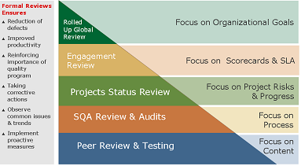

Figure 11: Review Matrix

**Audits:** Audits are supplementary activities that provide an independent view of the status of an engagement and its components. Engagement audit-result will be discussed with SOK and the concerned Service Delivery Manager (SDM). Various process audits will be conducted throughout the engagement. The engagements are also exposed to Internal and External audits to audits that ensure compliance to ISO 9001, ISO 20000, ISO 27001 standards & CMMI Services Model

### Corrective Measures

Corrective measures are normally invoked if the engagement deviates or is seen to deviate from its stated goals. Corrective measures get the project out of a red scenario and bring it to a more stable state by highlighting risks/issues through various means like weekly status reports, Quality Manager Report and Flagship Project report to Project teams and senior Management.

**Root Cause Analysis (RCA):** As a CMMI Level 5 organization, Root Cause Analysis (RCA) is carried out on a defined frequency or event driven basis by the project teams. The triggers for RCA could be client complaints, an audit observation or non-compliance, reduced PCI (Process Compliance Index), variance in goals and metrics, lower than desired OTACE scores etc

**Flying Squad:** It is a review activity that is conducted for high risk engagements. Flying Squads are invoked for high risk engagements at bid stage or during the execution of the project to identify the engagements risks and issues and to mitigate them. Senior members from the leadership team take part in Flying Squad reviews of the engagements

### Continuous Improvement

One of the building blocks of Capgemini value proposition is its continuous improvement framework. This framework fosters a continuous alignment of the SOK engagement to the changing needs and priorities of the organization.

**OTACE:** OTACE (On Time and Above Customer Expectation) is the name of the customer satisfaction program of Capgemini. The extent to which clients are satisfied about the performance of Capgemini is an important condition for future success. Therefore achieving SOK satisfaction is a main quality goal of Capgemini.

**Knowledge Management and Acquisition:** Learning courses to staff are disseminated through the Capgemini University. Our staffs also need to undergo 96 hours of mandatory training every year. Best Practices and Lessons Learnt are captured well and ensured that it’s been practiced.

**Process framework:** The continuous improvement infrastructure that is used within Capgemini comprises integration of best practices from various models like ISO, CMMi and Lean Six Sigma. This integration is necessary as there is no single, complete, off the shelf governance framework available that satisfies all our customers’ needs.

**Technology improvement:** Also, as a global IT services company; we constantly scan the market place and work with our alliance partners (Oracle, IBM, HP and others) to identify new tools/technologies and how they can be applied to benefit SOK and to enhance our service offerings for new clients.

Capgemini will continually work with SOK to ensure the quality services are delivered and any issues will be resolved through the right governance forum. Capgemini’s management commitment to the engagement will further ensure the quality assurance.

## Quality Assurance

Capgemini has been developing and improving our capabilities and processes over the past 40+ years of our existence. Our core business is to deliver high quality solutions trans-nationally. DELIVER™, Capgemini’s global methods environment, is a vehicle supporting this knowledge sharing. The DELIVER™ methodology is built upon the foundations of internal and industry standards, including CMM, Six Sigma, Lean, QMS, PMBOK and ITIL.

Capgemini’s Quality and Testing methodologies and practices are based on a solid framework that promotes consistency and flexibility to provide alignment to SOK requirements. This ultimately presents SOK with the benefit of improved quality and predictability, while ensuring a value for money service.

Capgemini has a robust quality and compliance group that covers functional areas such as: Quality Management, QMS Administration, Training Administration, Internal Audit, Corrective Action and Preventive Action (CAPA), System Engineering Process Group, Process and Product Quality Assurance (PPQA), and SAS70 Audit Reporting. Each of these areas contributes to providing product and process quality.

**Quality Management System (QMS) –** Capgemini’s Quality Management System (QMS) holds our Policies, Procedures, Work Instructions and Templates. The QMS includes our implementation of two leading industry standards for quality: ISO 9001:2000 and SEI's Capability Maturity Model integrated (CMMi). The QMS is further fortified by two types of reviews: peer and independent third party. In addition, each engagement or services agreement is assigned a Capgemini executive to serve as a Risk Management and Quality Assurance officer.



Figure 12: QMS Process Asset Library

The Capgemini QMS will be tailored to meet the requirements of SOK. During the Transition phase, we will work with you to formally document and publish a Service Quality Plan (SQP - Process and Procedures manual) based on the QMS standards. The SQP defines the set of procedures and standards implemented and applied by the Service Centres during the life of the service engagement to fulfill the quality and technical requirements for SOK. The SQP provides the foundation for the quality of service required to achieve the service delivery targets. As the SQP provisions change, the Capgemini Service Delivery Manager will revise this document.

The Capgemini QMS is constantly updated and upgraded based on internal learning as well as updates from CMMi, ITIL and other industry standards. The updated QMS is baselined and is made available to all the Capgemini teams. This ensures that all process improvements are adopted consistently across all the teams, globally.

Thus Capgemini will continually work with SOK to ensure the quality services are delivered and any issues will be resolved through the right governance forum. Capgemini’s management commitment to the engagement will further ensure the quality assurance.

The structure of the QMS is as show in the below diagram



Figure 13: QMS Structure

Thus Capgemini’s Quality Management System (QMS) holds our Policies, Procedures, Work Instructions and Templates. Capgemini employs a number of industry standards, models and leading practices (such as: ITIL, CMMI, ISO, Six Sigma, COBIT and COSO) in order to assist in addressing service quality. Capgemini’s approach to Quality Management encompasses:

* CMMI Maturity Level 5 and ITIL supportive processes, including Work Product Reviews, Testing, Quality Gates and Release Management. These benefit from continuous improvement using LEAN and Six Sigma approaches
* Our Delivery Review process, which provides for client and business focused quantitative management and improvement of processes at organization and account levels
* Visual Management – a daily dashboard monitoring the status of critical account KPIs
* Balanced Scorecard and Snapshot reports used by management to monitor client satisfaction across the business
* A statistically informed and managed audit process

The overall Quality Management system within Capgemini, be that CMMi and ITIL, benefits from the application of LEAN and Six Sigma approaches which address continuous improvement. The application of Continuous improvement through the use of LEAN and Six Sigma approaches gives the Department assurance of the continued relevance of Capgemini’s Quality Systems. All our processes are CMMi level 5 assessed and ISO 9000 certified, we have consistently delivered high quality deliverable to our clients.

## Capgemini Customer Satisfaction Process

We aim to achieve client satisfaction on all our engagements, delivering on-time and meeting or exceeding client expectation. We find it useful to have a formal mechanism to assess that satisfaction to provide feedback throughout an engagement on those areas where we are doing well and, just as importantly, on those areas where we need to apply improvements.

Some clients have their own assessment processes or particular requirements for an engagement which we’re very happy to work with. Where that’s not the case, the Capgemini Group has its own process known as ‘OTACE’ (On-Time & At or Above Client Expectation).

OTACE is not about measuring contractual effectiveness – it enables us to engage with our clients to understand their business needs and expectations to help deliver lasting results with tangible benefits.

Capgemini desires to achieve a high level of client satisfaction. To accomplish this objective, the organization has put in place a worldwide program that is used to set client expectations and measure satisfaction. This program will be used throughout the mandate by assessing and enhancing the quality of our work and our client relationship. To achieve quality performance, Capgemini has developed a client satisfaction measurement process for Capgemini’s internal use:

**Process flow of OTACE:**

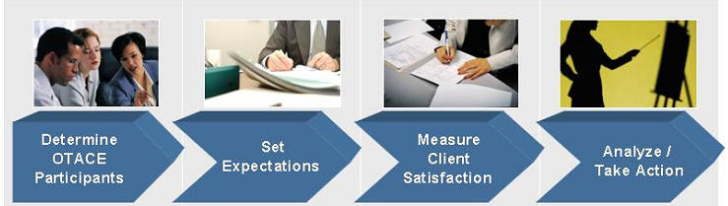

Figure 14: OTACE Process Flow

OTACE consists of a set of processes and procedures to gather information and produce reports. The process involves the following basic steps:

* Identifying Client participants who will participate in the process of setting expectations and measuring satisfaction;
* Capturing Client expectations for the engagement;
* Measuring performance against those expectations during the project; and
* Analysing interactions with Client and taking actions to continuously improve.

OTACE is a rating designed to measure the level of client satisfaction and “on-time” performance with the engagement. The Client must be consulted for building the ACE criteria and regularly reviewing the engagements rating against these during regular meetings or at specific OTACE review meetings.

## Audits

**Quality audits**

The Quality Management System at Capgemini India is compliant to various process frameworks including ISO 9001, ISO 20000, CMM SVC Level 5, ITIL , and ISO 27001.

 Internal Audits conducted at Capgemini for verifying compliance to our Quality Management System and the above-mentioned models.

Capgemini has a dedicated Internal Quality Audit team that performs the internal audit.

Internal Auditing Lifecycle

 Figure 15: Internal Auditing Lifecycle

Plan for Internal Audits

* Audits are planned based on predefined criteria like phase, type, complexity, risks involved etc with a minimum frequency of once in a quarter.

Support groups like ITICS, Staffing, L&D, ITP, Non ITP and ISMS gets audited during every external audit also once in a year by Quality team.

Track and conduct Internal Audits

* Track the audits planned and conduct audits as per the schedule
* Details the observations/ non conformances in the audit report and track them to closure

Publish audit results to Senior Management

Analyze Audit activity

* Analyze audit findings & Implement improvement activities based on analysis
* Communicate the analysis done to Top Management in Quality Council meeting.

External Assessment:

 Capgemini quality team facilitates and participates during the conduct of the external audit. Senior Management at Capgemini ensures that the audit comments are closed in the organization and necessary improvement actions are triggered for ongoing process compliance.

Third Party Assessment:

Third Party Audits are performed by agencies, independent of both Customer and supplier, recognised as competent to assess quality management system against a Standard. In recognition of meeting the requirements of the standard the supplier will achieve certification to the standard.

In addition to our formal processes, Capgemini recommends a joint audit to be conducted by Consulting and your internal audit staff be assigned to the program/project to confirm that all components of the implemented solution (redefined business processes, application security, etc.) are in adherence with corporate policy. The internal audit resources will provide the Capgemini implementation team with insight into current company practices and in return will gain first-hand knowledge of the system and process changes being implemented.

## Capgemini Quality Standards, Awards and Certifications

Below table depicts the details of various certifications holds by Capgemini India Non FS Business unit:

| Certifications | Certification Effective Date | Certification Expiration Date | Certification Body | Certification Description |
| --- | --- | --- | --- | --- |
| **ISO/ IEC 27001:2005** | Sep-13 | Aug-16 | BSI ( British Standards Institute) | ISO/IEC 27001:2005 is an Information Security Management System (ISMS) standard published in October 2005 by the International Organization for Standardization (ISO) and the International Electrotechnical Commission (IEC). Its full name is ISO/IEC 27001:2005 – Information technology – Security techniques – Information security management systems – Requirements. |
| **ISO 20000** | Nov-12 | Dec-15 | BSI (British Standards Institute) | ISO/IEC 20000 is the first international standard for IT service management. It was developed in 2005, by ISO/IEC JTC1/SC7 and revised in 2011. |
| **ISO 9001:2008** | Dec-13 | Dec-16 | ABS Quality Evaluations | The ISO 9000 family of quality management systems standards is designed to help organizations ensure that they meet the needs of customers and other stakeholders while meeting statutory and regulatory requirements related to a product. ISO 9001 deals with the requirements that organizations wishing to meet the standard must fulfill. |
| **ISO 14001** | Jul-14 | Jun-17 | BSI (British Standards Institute) | ISO 14001 sets out the criteria for an Environmental Management System (EMS). It does not state requirements for environmental performance, but maps out a framework that a company or organization can follow to set up an effective EMS. |
| **AS 9100** | Apr-11 | Apr-14 | ABS Quality Evaluations (Recertification done in April 14. Certificate is awaited) | AS9100 is a widely adopted and standardized quality management system for the aerospace industry. It was released in October, 1999, by the Society of Automotive Engineers and the European Association of Aerospace Industries. |
| **TL 9000** | Jan-14 | Mar-15 | UL Management System & Solutions | TL 9000 is a quality management practice designed by the QuEST Forum in 1998. It was created to focus on supply chain directives throughout the international telecommunications industry. |
| **CMMI SVC V1.3 Level 5** | Dec-12 | Dec-15 | QAI | CMMI was developed by a group of experts from industry, government, and the Software Engineering Institute (SEI) at Carnegie Mellon University. CMMI models provide guidance for developing or improving processes that meet the business goals of an organization. A CMMI model may also be used as a framework for appraising the process maturity of the organization. |
| **SSAE 16 / ISAE 3402 (*erstwhile SAS 70*) Type II Audit Report available with risk team** | Latest for the period – Jun 2013 – Jan 2014 | Jan -14 |  | Statement on Auditing Standards No. 70: Service Organizations, commonly abbreviated as SAS 70 and available in full-text by permission of the AICPA, is an auditing statement issued by the Auditing Standards Board of the American Institute of Certified Public Accountants (AICPA) with its content codified as AU 324. As of June 2011, the Statement on Standards for Attestation Engagements No. 16, Reporting on Controls at a Service Organization (SSAE16), replaces SAS 70. SAS 70 provides guidance to service auditors when assessing the internal control of a service organization and issuing a service auditor’s report. |

**Quality Awards and Recognition received over the last eighteen (18) Months:**

* **NIQR- National Institute for Quality & reliability**
* April, 2014- won Platinum award for project on “Optimizing On-Boarding process of New Joiners” under LEAN category
* April, 2014- won Silver award for project “Increase in resource productivity of a IM Project” under DMAIC IT/ITES category
* **Indian Statistical Institute -**
* Jan, 2013 - Six Sigma Conference at Mumbai wherein our presentations were adjudged with “Best Presenters”
* Feb, 2013 – Won first prize in ITES Category for Staffing Turnaround Time Improvement in Recruitment Process and special prize in IT category for Reduction of Turn Around time for SAP
* Feb, 2013 – Won special prize in IT category for Resolution time reduction in the project.
* Mar, 2013- Won Best Project Award for Paper presentation held for LEAN – Six Sigma project at Bangalore.
* **SCMHRD Awards –**
* Oct, 2013– 1st Runners Up LSS project on “Recruitment TAT improvement for Infra”

Nov, 2012– Short-listed for final presentation at National Level, based on successful implementation of LEAN – Six Sigma program at Capgemini India

Additionally, Capgemini conforms to the ITIL® framework for its service delivery and has more than 7,500® ITIL certified resources wherein:

* 10% of Service Delivery personnel are ITIL® v3 Master Certified
* 35% of Service Delivery personnel are ITIL® v3 Practitioner Certified

55% of Service Delivery personnel are ITIL® v3 Foundation Certified

# Solution Description

## Capgemini Understanding of SOK requirements

Capgemini understands SOK’s strategic direction as stated within the RFP for the EAI landscape. We understand that SOK is eager to have a supplier who can help to research and identify SOK’s Data transmissions integration services’ alternative solutions. The objective is to find best possible service providers, most recent service models and those approaches of service implementation that suit best the current state and development target of SOK. SOK expects Capgemini to offer both maintenance and development of SOK’s Integration service.

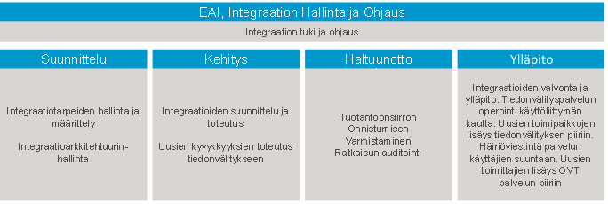

Figure 16: Requirement understanding

## Solution Overview

Capgemini’s Value Proposition to SOK

* Our understanding of the SOKenvironment and alignment to SOK’s strategic goals
* Rightshore® Delivery Model – blend of local and offshore capabilities for business success.
* Cost effective services
* Future proof and scalable service supporting new technologies to secure your businesses’ IT.

Our work with SOK over the last years has given us an unmatched insight into your business objectives, IT vision and the importance of making that vision a reality. We are also excited to be offered the opportunity to respond to the SOK - EAI proposal for support of your EAI landscape. Capgemini recognizes the criticality of these functions and services to your core operations and we are confident that your business will be secure with Capgemini.

Capgemini has a track record of consistent and innovative delivery. We commit to work closely with SOK to customize our services to meet the dynamics of your business. Our approach is driven by the philosophy of Continuous Improvement and value-additions, improved application usability and stability to help the S Group’s businesses have higher productivity and improve application robustness and maintainability, thus achieving reduced overall Total Cost of Ownership (TCO) for SOK.

**In developing our solution for SOK we have used the following principles to guide our solution:**

* Ensure a smooth and stable transition while striving for speed
* Provide focused onshore support in Finland to ensure the right level of relationship and service management in these geographies
* Utilize a highly leveraged Rightshore® model to provide significant cost savings. Establish the centralized support team in our centre in India
* Seamless Integration of our services, thus allowing SOK to have a single point of entry into the service model
* Provide a flexible pool of resources for supporting enhancements and give SOK a degree of control over variable costs, in line with business priorities
* Ensure innovation, continuous improvement is ingrained in the service delivery and also actively plan and drive initiatives to deliver real gains
* Ensure that our service delivery model caters for the changing nature of the SOK’s IT application landscape – flexibility, adaptability are key

#### The key elements of our on-going service delivery are:

**Service Levels:** Capgemini will deliver your service to the agreed and transparent service levels as outlined in the RFP.

**Service Governance:** The major aspects of our Governance and Management will be conducted from our onshore offices in Finland. On an operational level, some operational meetings with SOK will involve our delivery management from our Indian centres, but fundamentally your service delivery will be managed by the Delivery Executive and his senior management team in Finland.

**Rightshore® Approach:** In today’s challenging economic environment, businesses are seeking to reduce costs & enhance growth and SOK is no exception. SOK can achieve these goals with a scalable approach to global delivery and sourcing that combines quality, efficiency, talent and collaboration., Using Capgemini’s Rightshore® approach , we bring together our best talent from the right balance of onshore, nearshore and offshore locations and work with you as a unified team. It’s by getting this balance right that we are able to deliver an optimum solution that will help you reduce costs and enable you to focus on growth, innovation and sustainable competitive advantage.

**Client Speak:**

*"We were searching for a solution to reduce our costs while maintaining consistent service levels, improving staffing flexibility, and providing access to leading IT practices. The Rightshore® model allows us to always have the best skilled employees at the right time and place and at the right cost. In addition Capgemini work with us to blend Tenneco and Capgemini best practices to create an efficient delivery model."*

**Bill Haser, CIO, Tenneco**

**Processes and Best Practices:**

*DELIVERTM - Our ITIL Compliant Service Delivery Methodology*

We will introduce our global quality methodology DELIVERTM, to ensure best practise in project and service delivery. Capgemini is committed to the principles of quality IT Service Management embodied in the IT Infrastructure Library (ITIL) and our service delivery methodology contained within DELIVERTM which is based on ITIL.

We will introduce Service Support processes for focussing on the areas of Incident, Problem, Change, Release and Configuration Management.

*Our Quality Management System*

Capgemini’s Quality Management System (QMS) holds our Policies, Procedures, Work Instructions and Templates. It is described in detail in Section 4. The QMS includes our implementation of two leading industry standards for quality: ISO 9001:2000 and SEI's Capability Maturity Model integrated (CMMi). All of the Capgemini delivery centres are aligned with CMMi, with our offshore locations in India being complaint to ISO 9001:2000 Model, CMMi Level 5 and ISO 27001 Information Security Model. Our architects and subject matter specialists review project work products and deliverables at appropriate milestones to measure quality and compliance with ISO and CMM standards.Our quality related capabilities, certifications and continuous improvement processes have been described in section 4.

*Continuous Improvement*

Capgemini teams operate on the philosophy of continuous improvement using our maintenance techniques to gradually move from a support regime to a proactive regime, with the aim of reducing the absolute numbers of support incidents. Continuous Improvement will be at the heart of our service delivery to SOK.

The Capgemini solution will enhance SOK’s ability to provide enterprise wide application and infrastructure services by implementing centralized, standardized and simplified processes using the Rightshore® delivery model. The value of this approach includes:

* Allowing management to focus on higher value add tasks, such as strategic planning for the business
* Ability to manage with enterprise Service Level Agreements
* Better management decisions by having more complete operational information available
* Ready access to a strong and deep bench of expertise and staff
* Cost savings
* The foundation of our proposal is our commitment to deliver lower cost and increased value to SOK. During our engagement with SOK we will:
  + Ensure no interruption of mission-critical day-to-day operations
  + Increase the quality and availability of services by leveraging our Rightshore® delivery centres

Capgemini’s strength lies in the excellence of our delivery team, our adoption of leading practices that support the quality and balance of our solution, and the absolute commitment of our senior executives to the success of the SOK relationship. These are key elements that portend success of the outsourcing initiative and achievement of your objectives.

Simply put, our people, approach and track record make the difference. Like your associates, ours bring passion to the job at hand, in our case, for service and operational excellence, and a relentless focus on speed-to-value.

## Application Maintenance Services

Capgemini’s solution for SOK consists of having a team onshore and technical competency teams located at remote delivery centres. These combined, highly knowledgeable and skilled teams will work on a day-to-day basis with SOK on projects, enhancements, maintenance and IT improvement initiatives.

After understanding SOK’s business requirement, following AMS services are proposed:

**Application Management:**

Capgemini provides extensive management of an application or of a portfolio of applications. The Service Desk will be responsible for addressing the production issues. Some of the production issues will need an in depth analysis and extensive code correction. Such requirements will be assigned to the Capgemini development team as change requests. Capgemini team will be servicing these change requests with well-defined processes to enhance cost savings, continuity, quality and flexibility. We take a robust lifecycle view of applications, and focus on the continuous improvement of the portfolio ensuring applications support the evolving needs of the business. Capgemini moves beyond “keeping the lights on for less” by embracing an approach that is committed to the continuous improvement of the application landscape and helping clients extract maximum value from existing and future IT investments.

**Middleware and Database Support**

For the SOK-EAI middleware and database support, our proposed solution will have offshore delivery capabilities – Capgemini India. Capgemini Service desk from Finland will be Single Point of Contact for technical & functional requirements of SOK and responsible for interfacing with SOK-EAI’s technical management team and have weekly connect calls.

The India offshore delivery centre provides technical support, incident, problem, change and release management for middleware and database products.

Offshore delivery team also coordinates with the onsite service desk teams for incident resolution and keep service documents up to date.

**Approach to Technologies**

Capgemini will make sure SOK-EAI’s middleware components/applications support are in alignment with ITIL processes and best practices and therefore we will put emphasis on mechanisms to drive support efficiencies and increase the availability of SOK-EAI integrations

Our approach to SOK-EAI operations for the middleware and database RUN Phase is based on shared model which will be supported from India

Over a period of time, Capgemini has invested heavily in building a network of global delivery centres utilizing the same tools, process and procedures. Capgemini will utilize our Distributed Delivery Model to deliver support services. We use the approach to blend on-site, on-shore, near-shore and off-shore delivery elements into the service.

The Support Team will be responsible as part of the services for:

* **Problem Management** - Tickets which are constantly occurring will be brought under problem management to be resolved by experts using root cause analysis
* **Support maintenance** - Maintain middleware, database application to supported releases- Application of patches in a cumulative manner, or piecemeal as a result of a particular problem.
* **Preventative Maintenance** - Regular review of knowledge base to allow known faults to be fixed prior to encounter serious errors.
* **Performance Analysis and System Tuning** - Performance data collection and reporting with recommendation of hardware or software alterations to improve systems/application performance.
* **Maintenance of best practice** - Configuration complying with best practice dictated by the providers, and on-going maintenance of the systems documentation
* **Software Vendor Alignment** - All liaisons with software (middleware, database) providers when required to have product knowledge.
* **Vendor Coordination** - To coordinate with the third party vendors, who are responsible for infrastructure support of middleware and database components through Capgemini service desk located in Finland for any dependencies related to SOK-EAI middleware and database operations example monitoring, networking, etc.

**Middleware Administration**

Middleware support is provided remotely by a support team located in Capgemini’s Rightshore® Delivery Centre. Capgemini’s support team is a shared pool of accredited technical support analysts who will provide support for middleware.

Capgemini’s technical support teams are in charge of the day-to-day operations of the middleware integrations and are available to provide remote second line support. This includes the management of technical incidents that occur on the connected systems middleware applications on a day-to-day basis.

The monitoring support for SOK is assumed to be performed by a third party vendor (Non-Capgemini) and the tickets generated through the alerts by the third party vendor are integrated with Capgemini’s BMC Remedy ITSM ticketing tool to facilitate 24x7 support of the middleware applications from within our delivery centre.

Capgemini identifies that the below technologies are under scope and also suggests that Capgemini will be able to support the upgraded versions or latest versions of the identified technologies.

The following Middleware technologies which have been identified as part of the RFP

* IBM Broker
* IBM WebSphere MQ
* IBM WebSphere Application Server
* IBM HTTP Server
* IBM DataPower Service Gateway XG45

**Database Administration Support**

Our Technical Services Solution Centre delivers skilled technical support for SOK EAI services from our Indian centres and provides economies of scale and standardized processes.

The Capgemini database team has extensive experience in providing database administration and support and has developed all the necessary standards and procedures to ensure high system availability and high quality support for the SOK-EAI landscape which is using DB2 as backend database. Capgemini provide a range of database administration functions, including logical and physical database administration, data architecture, and performance management for DB2 databases for the scope of SOK related with EAI support.

### Ticket Flow Model (Workflow)

***Seamless connection among client teams and Capgemini Application Maintenance and Development***

SOK-EAI’s users will be able to log tickets for EAI related support with Capgemini service desk in Finland either through phone or mail.

Service desk will analyse the tickets and do the necessary routing of tickets to the appropriate teams in offshore, onsite or resolved by service desk team. The routing of tickets and support analysis of tickets will be performed through Capgemini service management tool (BMC Remedy ITSM tool).

This shall allow bi-directional flow of information on incidents & problems. Incidents reported in infrastructure vendor Service Desk shall get replicated in ITSM to allow Capgemini Service desk consultants to access the same. Incidents reported to Capgemini’s integrated BMC Remedy ITSM Service Desk will be assessed by our Operations staff and directed to the appropriate support contact.

When the incident requires additional information, the offshore application leads will involve onshore consultants to interact with SOK EAI leads and gather the required information for resolving the incident. Our onshore staff will also be involved in case of high priority incidents. They will work closely with offshore team and maintain the necessary communications with SOK EAI personnel until the issue is resolved.

The delivery managers at offshore will be responsible for managing ticket escalations, tickets breaches and major issues and incidents through ITSM instance on Capgemini side. Should issues require escalation, the onshore delivery manager will be engaged to address concerns and meet with SOK to ensure that work efforts are appropriately directed to resolve issues in conformance with customer expectations and Service Level Agreements.

#### Flow of incidents across teams within SOK and Capgemini



Figure 17: Flow of Incidents across teams

For any EAI middleware support, integrations and database administration related incidents Capgemini will follow the subsequent steps:

* Automated alerts for middleware and database are routed from SOK infrastructure vendor to Capgemini ticketing tool (BMC Remedy ITSM) via SD2SD integration.
* Capgemini team responsible for support of middleware and database will monitor the tickets in ITSM and assigns to the respective queue.
* The support team from (EAI streams of middleware or database) will analyse based and resolve the issue.
* The resolution will be updated in the ITSM as part of ticket closure.

In case of the issue is analysed to be related with code, the support team approaches the application development team to fix the issue. The application development team will coordinate with all the stake holders and fix the issue.

Capgemini’s client-facing teams will interact with SOK team members through established standardized work-based processes, and will include onshore service delivery managers and architects / analysts. The Capgemini India delivery centre based team is the primary point of delivery.

Our client-facing and delivery centre teams work together seamlessly, facilitated by our standard tools and processes.

Our understanding of the scope is as follows:

* Incidents: Will be handled by the Service Desk (Level 1), Level 2 and Corrective maintenance i.e. level-3 support. Level 1 and Level 2 support includes user support and service requests respectively.
* Service Desk will assign the production issues - Level 2 and level 3 tickets to the teams of Capgemini.

Requests for change/minor enhancements will be informed to Capgemini Finland business analyst. The Capgemini Offshore teams will then work on the requests after they receive the necessary documented requirements from the business analyst.

The SDM oversees the activities of the maintenance team. The SDM will work in co-operation with the Capgemini team and SOK IT to ensure seamless delivery.

### Service Delivery Model

We believe the proposed delivery model depicted below is cost-effective and has a risk-balanced approach.



Figure 18: Proposed Service Delivery Locations

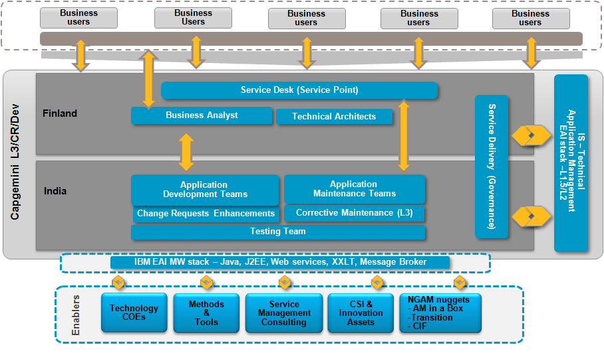

Figure 19: AMS Delivery Model

The key features of our delivery model are:

* Service Delivery Manager (SDM) in Finland helps to facilitate interaction between various Capgemini delivery and SOK
* Centre-based offshore delivery in India that will allow for industrialization
* Intimacy with SOK IT and business representatives through client-facing teams
* Business analysts to understand business requirements and to provide consultation
* “One Team” to provide seamless delivery to the SOK
* Leverage existing EAI service desk in Finland.
* EAI support team in India
* Utilize existing monitoring infrastructure to provide EAI related monitoring.
* Capgemini service desk as SPOC for all EAI users

Our service management team will be located at Finland providing close proximity to where the services are consumed. In our experience this allows your team to develop a close working relationship with our delivery team and facilitates a communication channel sensitive to local culture and local language This team will work within the overall governance framework that consists of both in-country and remote delivery centre delivery managers managing the end to end services – we call this the “One Team” approach.

### Service Levels

As per the RFP documents shared Capgemini will adhere to the requested Response time SLA. Capgemini proposes to have a mutually agreed resolution SLA with SOK which can happen during the next stages.

Capgemini will also adhere to the availability target of 99.9% for the support requirement.

|  |  |
| --- | --- |
| SLA | Response |
| Severity 1 (P1) | 15 minutes |
| Severity 2 (P2) | 30 minutes |
| Severity 3 (P3) | 1 Business Hour |
| Severity 4 (P4) | 4 Business Hours |

For Change requests, the turnaround time will be agreed on a case to case basis

### Service Delivery Process

#### Capgemini will implement industrialized service delivery processes such as incident, problem, change, release & deployment management and the like.

#### Service Desk

Capgemini Service Desk is the central point for contact between the client users, infrastructure services and the service. The Service Desk handles Incidents and Service Requests and provides an interface for other activities such as inquiries related to ticket statuses. These services are delivered using ITIL processes and using enterprise toolsets. The services are delivered 24x7 and they will support English and Finnish languages.

The BMC Remedy ITSM tool used by the Service Desk is integrated with infrastructure vendors’ ITSM tool so that tickets and the information contained in them can be passed to both directions. Users will have a number of access options to the Capgemini Service Desk, including telephone, email and self-service portal.

#### Reporting

We will set up a service reporting function during transition as part of our support service that provides accurate data and reports on an on-going basis in order that the Service Managers can meet the requirement for supplying standard, timely and consistent information. This service reporting function will be responsible for collecting, analysing and reporting on the information provided by Capgemini’s service management tools. The type and content of the service reports will be agreed and built during the transition phase.

The following are sample reports we can offer:

| No | Report Name | Frequency | Description |
| --- | --- | --- | --- |
| 1 | Weekly Incident & Problem Reports | Weekly | Report on all medium to low priority incidents / problem tickets raised during the week |
| 2 | Incident /Problem Summary Report | Monthly | Monthly incident/problem report by priority, by problem type, by division |
| 3 | Change Summary Report | Monthly | By category, by resolution category, with a year to date trend |
| 4 | Service Management Report | Monthly | SLA Performance report |
| 5 | Customer Satisfaction Survey | Bi-annual | Undertaking the survey and publishing  the results |
| 6 | Performance Review Report | Annual | Annual trends including incidents, major achievements, issues, SLA performance |
| 7 | Ad hoc reports | As needed | These are reports which can be produced on demand. |

#### Service Management Reports

The contents of the service management reports will reflect achievements against targets that have been agreed with SOK during Transition. Typically a standard template will be used. This usually contains, as a minimum, the following items:

* An executive summary;
* Performance against the SLA;
* Call data and trend analysis;
* Status of applications;
* Status of each service discipline;
* Status of service improvement plans;
* Status of problems and known;
* Details of changes and other future activities; and
* Financial summary.

#### Service Level Monitoring

Operational reports will be produced frequently and where possible, exception reports will be produced whenever a SLA target has been breached or threatened (where possible appropriate thresholds should be set to give an “early warning”). Where warning is given that a threshold is at risk, internal escalation procedures should be invoked in order to prevent the SLA being breached.

Periodic internal reports will also be produced incorporating details of performance against all SLA targets – an SLA monitoring chart is a useful tool for giving an “at a glance” overview of achievements against targets. It is recommended that these are colour coded (Red - Amber - Green). This chart may subsequently also be included in the service report presented to SOK. Other internal reports may be required to monitor performance of internal support teams against Operational Level Agreements (where relevant) and to monitor the performance of third party suppliers against any underpinning contracts.

Capgemini’s Service Management team will investigate areas where targets are not being met. Particular attention will be focused on any breach of agreed service levels to determine exactly what caused the loss of or degradation to normal service. Actions will be taken to prevent recurrence. It is recommended that any actions should be managed as a service improvement plan.

If it is decided that the Service Level was, or has become, unachievable, it may be necessary to review the service targets with SOK and negotiate appropriate targets. If the breach has been caused by a failure of a third-party, it may be necessary to review the underpinning contract or if the breach has been caused by a failure of an internal support team, it may be necessary to review the Operational Level Agreement where one exists. (Note that all agreements should be reviewed periodically).

Monthly review meetings with the SOK will be used to examine the service achievement against targets during the previous period and review any impending issues for the future.

The frequency of the reports for SOK may vary from daily, weekly to monthly reports based on agreement with SOK during SOW phase. Some more sample reports is given below:

|  |  |  |
| --- | --- | --- |
| Report | Description | Sample Screenshot |
| Demand Reporting | Capgemini will provide guidance to where required to ensure that there is a well structured quarterly rolling demand pipeline and forecast mechanism in place, and Capgemini will provide accurate reporting on utilisation, forecast accuracy, and demand patterns. |  |
| Weekly Operations Report | Weekly report providing details like:   * Ticket trends for last 7 days * Issues escalations and resolutions * Status updates, etc. |  |
| Critical Systems Availability Report | Monthly Report showing:   * Critical and key systems availability * Red/Green/Amber availability |  |
| Management Summary Report | Monthly report containing:   * Summary of incidents/problems raised and closed that month, measures and risks * Summary of changes raised and completed that month * Current projects * Summary of planned activities * Improvements to applications * OTACE results (client satisfaction) * Follow-up on actions |  |

Figure 20: Sample Reports

## Application Development

### Approach – EAI Methodology

***Capgemini Key Differentiators***

* Experience in development and maintenance of EAI projects
* Ability to adapt to new technologies – for example DataPower capabilities
* Leverage the SOA Center of Excellence and Integration Competency Center

Capgemini uses EAI methodology for development and maintenance of EAI/SOA projects. EAI methodology specifies the methods to create frameworks, architectures, and templates that will help our clients to define and design solutions that are comprehensive and consistent. A sound architecture and structured framework is vital for the success of a development project, the way smooth transition is for an AM project. EAI methodology is actually a blend of the Rational Unified Process and modelling language (UML). The methodology in itself is a process that defines the steps necessary to complete the analysis, design, construction etc. UML uses the graphical models that a methodology needs to represent within a process. This methodology has been proven in numerous engagements and is both scalable and reusable.

The EAI methodology becomes the means for us to define and refine processes for different domain and practice within the Capgemini. Such as development, maintenance and migration project, where we need to focus on Architecture, capacity planning, performance, physical and logical architecture, project initiation and justification, operational service level agreements, etc.

RUP’s iterative nature and focus on architecture early in the process are particularly well suited to EAI. Our EAI methodology is based upon the Rational Unified Process (RUP) and is broken into the phases of Inception, Elaboration, Construction and Transition.

The overriding goal of the Inception phase is to achieve concurrence among all stakeholders on the EAI high-level vision for the project. The Inception phase is particularly important for new infrastructure efforts. These projects require that the baseline frameworks be driven out early in a project lifecycle to assure success. Clear and early direction mitigates risks for later phases of the infrastructure project.

Throughout these Inception phase, four main streams of work will define the activities to deliver the EAI architecture. These threads include:

**Business Architecture thread will define:**

* EAI functional requirements (e.g. workflow, data transformation)
* EAI Business Transaction Application Integration Framework
* Knowledge transfer model
* Support organization model

**Application Architecture Thread will define:**

* EAI software components
* Connectivity model to platforms (e.g. application, database)
* Templates and process for integration

**Technical Architecture thread will define:**

* Physical distribution of EAI infrastructure components
* Operational support model (e.g. configuration management)

**Technical infrastructure requirements (e.g. servers, networks)**

* Data Architecture thread will define:
* Synchronization Approach
* Data transformation templates
* Data Management framework

**Enhancements:**

We also deliver minor and major enhancements and/or upgrades to address changing business requirements. These enhancements are typically the ones that are supported by the Application Management Teams, while the larger projects will be supported by the Application Development team. Applications are designed, built and supported by our Accelerated Solutions Environment, Advanced Delivery Centres and Applications Management Service Centres, which form a part of our Rightshore® global delivery network.



Figure 21: Project Phases

*Elaboration:*

The goal of the elaboration phase during an EAI project is to develop detailed specification for implementation of EAI components. This will include EAI functions such as workflow, monitoring and data transformation. At the conclusion of the elaboration phase a baseline for the project plans and EAI solution will be defined and support the effort in the construction phase.

*Construction*

The primary goal of the Construction phase is to finalize all remaining requirements, document the solution definition, and complete the implementation of the EAI components according to the baseline architecture.

*Transition*

The focus of the Transition phase is moving from the development environment to the production environment and availability of the EAI infrastructure. The Transition phase can span several iterations, since it includes some system testing of the product, which may require iterations for fixing defects or configuration issues. The Transition phase also includes some user acceptance testing of the product, which could mean minor adjustments based on feedback.

Running throughout all RUP phases are four threads of architecture: business, application, data, and technology as previously discussed in the Inception phase. The definition of templates and frameworks primarily occurs in the Inception phase, with their actual use occurring in the Elaboration Phase.

### Integration Factory

Through years of experience with software development Capgemini has built a factory model for distributed delivery, which has been perfected based on the large number of successful projects that have been delivered. Integration factory consists of the following components:

**Architecture Review Board:**

It will be a joint architecture review board consisting of Architects from SOK and Capgemini. They will update the integration architecture landscape based on the new requirements, design the interfaces, review the design, provide the following:

* Best practices for design
* Design guidelines, patterns and templates

**Architecture Review Board for design guidelines, patterns and templates.**

Source Control Management

Build Management

Test Management

**Source Control Management**

* One central source code repository to facilitate version and change tracking, release management, source compare and merge, change history management

**Build Management**

* Continuous Integration, building the mainline application version at specific intervals to facilitate issue and project state tracking, to detect problems early

**Test management:**

* Testing at each build to enforce quality of code
* Unit testing, system testing and integration testing

**Continuous Integration:**

Early detection of defects

Jenkins & Sonar for Automated Code Analysis

**Reports and metrics**

* Facilitate project management by providing informative code reports and metrics

**Bug tracking system**

**Central project portal**

* Automated project site generation to facilitate project follow-up

**Project structure setup**

* Creation of a standardized development project structure
* Setup of developer environment

**Release management**

* Automated creation of product releases including major/minor versioning, artifact labelling and deployment to development, staging or production environment



Figure 22: Request flow

Capgemini’s Business Analyst will interact with SOK's business users to get the business requirements through established Standardized work-based processes. There will be requirements workshop organized with the business users. Architects may also participate in this workshops.

Business Analyst will develop the use cases/requirements specifications and get it approved by SOK. Once the use cases are finalized, it will be shared with the Architecture Review Board and Capgemini’s offshore team.

Architecture Review Board will consists of architects from SOK and Capgemini. Architecture review board will incorporate the changes in the architecture due to the new projects requirements. Architecture review board will also provide the best practices, templates, guide lines for integration,

The offshore team will create a design and get it reviewed by the architecture review board. Once the design has been approved the offshore team will implement it. Business analyst and the test team in the meantime will develop the test plans and system and integration test cases.

During the implementation the developers will develop the interfaces and unit test the interfaces.

The SDM oversees the activities of the development team. The SDM will work in co-operation with the Capgemini team and SOK IT to ensure seamless delivery.

### Continuous Integration



Figure 23: Development Environment

* Through continuous integration and ant, code will be build, validated and stored in the repository. This continuous process makes it possible to spot bugs / faults in the application as soon as possible.

Capgemini will put in place an integrated process to secure quality of the deliverables. This process will be based on automating various software measurements which provides quality indicators to facilitate an augmented and continual quality feedback of the software system. It reflects the true state of the software at any given point in time.

Capgemini will setup Sonar (<http://www.sonarsource.org/>) which will be integrated with Jenkins as a part of continuous integration process for Ant build creation.

Sonar is an [open source](http://en.wikipedia.org/wiki/Open_source) [software quality](http://en.wikipedia.org/wiki/Software_quality) platform. Sonar uses various [static code analysis](http://en.wikipedia.org/wiki/Static_code_analysis) tools such as Checkstyle, PMD, FindBugs to extract software metrics, which can then be used to improve software quality.

Sonar provides the analysis of the following software measurements:

**Architecture**

* Coupling Complexity: Average component dependency
* Design Anomalies: Coupling anomalies
* Dependencies and Cycles

**Source Code**

* Size: No of classes, lines of code
* Code Anomalies: Rule violations, findings, anomaly density
* Comments: Comment density, missing comments, inconsistent comments, commented out code.

**Tests**

* Test Success: Number and results of unit tests
* Test Coverage: Code coverage of unit tests

**Performance**

* Response Time: Use case execution times

Jenkins can be setup to trigger a sonar task based on the timer or during project build creation. It will generate an analysis report which will be automatically emailed to the registered users. The management dashboard will display the various metrics collected for Architectural violations, code quality.

### Test Automation

**Web Service Testing**

Services or SOA-based platforms are a collection of loosely coupled services that provide business services to multiple applications to deliver end-to-end support to business processes. Verification and validation of the interfaces and services (internal/external) that bring together diverse systems and platforms, coupled with allied performance and security considerations, make testing really complex.

As a testing team undertakes the job of testing Services either independently or as a part of application to which services are provided, they’re likely to encounter following challenges:

* No user interface for the services in the test environment.
* Dependency on availability of back-end applications (platforms) that are service wrapped to perform E2E testing.
* Availability of test environment which may bring together multiple application/services.

|  |  |
| --- | --- |
| Test Objective | To test and verify the individual services against the functional behavior. |
| Entry Criteria | 1. Service specifications document 2. Low Level Design document 3. Functional specifications document 4. Business requirements document 5. Unit Test reports 6. Test scripts |
| Task | 1. Create service level test plan 2. Review the Service Level Test plan 3. Prepare service level test cases 4. Review the service level test cases. 5. Prepare a traceability matrix. |
| Verification/Validation | Verification of Service Level Test Plan and Service Level Test cases. Executing the test scripts against the functionality. |
| Exit Criteria | 1. Approved Service Level Test Plan 2. Approved service level test cases 3. Service level testing execution report. 4. Defect reports, all the sev1 and sev 2 defects to be closed. |
| **Defects that can found in this phase** | Incorrect, unreasonable, Inconsistent, Incomplete, Ambiguous and Missing Requirement defects in Service specifications le, Inconsistent, Incomplete, Ambiguous and Missing Requirement defects in Service specifications |

**Web Services Performance Testing:**

Idenetified SOK’s framework services are in scope to test services behaviour under different loads, same test cases which are designed using CA Lisa can be re-used for performance testing purpose with minimum effort. Services/interface with different message type like XML,SOAP,Flat files, SWIFT, JSON..etc message over transports like HTTP(S), MQ, JMS, TCP will be undeer scope for performance testing.

Also we can use virtualization to support performance testing. If any down/up steams are not available for performance testing. If we have any virtaul services are designed for functional testing, same service can used for performance testing with minimum effort by modifying same as per non functial requirements.

**Web Service Virtualization:**

Capgemini ensures the quality and integrity of Service Virtualization in a continuous validation there by optimizing the development and delivery lifecycles in terms of Quality, agility and Cost savings.

As the scope of service virtualization is assumed, Capgemini proposes **CA Lisa** which is the market leading tool for Service Virtualization. The web services execution and virtualization can also be carried out using Ca Lisa. The Capgemini’s approach with CA Lisa for Web services Automation and Service virtualization is shown below.

SOA Testing approach using CA Lisa



Figure 24: SOA Testing Approach

**Service Virtualization Approach using CA Lisa**

Capgemini ensures the quality and integrity of Service Virtualization in a continuous validation there by optimizing the development and delivery lifecycles in terms of Quality, agility and Cost savings.



Figure 25: Service Virtualization Approach

Capgemini’s approach to Service Virtualization is performed in two steps. In the initial go, the automation test team designs and executes the test cases using SOA test automation tool like CA Lisa to test the behavior of the web-services /interfaces. Then, the Service Virtualization team creates and deploys the Virtual assets on the virtual server from where these can be accessed and modified.

Capgemini has the capability of testing these services using different transport protocols, SOAP, XML/HTTP, JSON/REST, XML, SWIFT etc., and with different messaging formats including Copybook.

**Below is high level approach for virtualization of services/interfaces for SOK’s frame work.**

* Due diligence to identify available services that needs to virtualized and automated
* Prioritization of services for virtualization based on business criticality and number of consumers
* Setting the virtual service Environment
* Design unit tested virtual services, Roll out for Integration and Test virtual service in integrated environment
* Setting up a team to maintain virtual services and perform service testing as BAU activity

### Future Proofing SOK IT: EAI, Service Oriented Architecture and DataPower – Capgemini Vision

#### EAI and Service Oriented Architecture

EAI (**Enterprise Application Integration**) is a framework that makes use of software and computer systems to enable data integration across applications within a single organization, while also simplifying business processes among connected applications and data sources. The sharing of data and business processes between applications are its primary purposes. However, EAI also defines a set of principles for integration of multiple systems for communication architectures, such as message-oriented middleware (MOM).

It serves as a system that can provide a business service to simplify information data between diverse applications, which makes it possible to easily integrate them when needed.

This discipline of integrating applications and data within the enterprise has been a critical component of today's enterprise strategies. In fact, many vendors offer EAI suites that provide cross-platform, cross-language integration solutions.

SOA deals with linking enterprise applications so they can communicate with one another (by means of an intelligent reasoning engine) and carry out “batch” data transfers, is the service oriented architecture (SOA) that provides “transactional” data transfers, with no third-party software required. SOA is different from the EAI approach in that it does not depend on a third-party solution.

SOA is an integration paradigm that is based on a fundamental design principle and provides architectural interoperable services - hence its name. It encompasses legacy systems, software components and message processing capabilities.

Its primary function is integration of services and the development of applications. SOA-based systems have become common because of development technologies and platforms and the changes in traditional IT roles and responsibilities. SOA has been the solution for business logic and technology.

SOA represents distinct principles that foster service-orientation in loosely coupled systems (like ESB where it acts as a broker between services), network change management governance and has become an important aspect of Web 2.0 applications and services.

#### Capgemini SOA and DataPower Capabilities

Capgemini understands that SOK wants to move the existing EAI landscape to SOA and wants to use DataPower XG 45.

IBM has 3 products of Data Power. We can leverage our existing partnership with IBM to get insights and suggest the DataPower appliances suited for SOK’s IT needs.

* IBM WebSphere DataPower Appliance XI52: It is used as Enterprise Service BUS
* IBM WebSphere DataPower Service Gateway XG45 Appliance: It is used as security gateway
* IBM WebSphere DataPower B2B Appliance XB62: It is used as B2B Gateway.

IBM WebSphere Data Power Appliance XG45: The IBM WebSphere DataPower Service Gateway XG45 appliance can be used to build a stronger application-security foundation. It can be used as a security gateway.

The DataPower Service Gateway XG45 provides:

* Light-weight connectivity, mediation and stronger security processing to your application infrastructure.
* Web service proxy for a more efficient gateway approach.
* Centralized policy and service-level management for compliance and for meeting service levels
* The ability to streamline complex but valuable SOA, XML and web 2.0 applications.
* Data validation for web 2.0 and for existing applications those are web-facing.
* The ability to shorten deployment times.
* Acceleration of XML and web-services processing.
* Strengthened governance of your valuable application infrastructure
* The ability to offload application encryption and decryption
* The ability to bring new services to the market more securely and more rapidly.

The ability to manage business-application risk, increase staff productivity and reduce maintenance costs.

Based on the understanding of the EAI landscape of SOK, Capgemini would propose to use Message Broker as the enterprise service bus and Data Power XG45 as the security gateway.

Message Broker could be used as Enterprise Service Bus (ESB) in the following scenarios:

* WebSphere Message Broker is currently used but not as an ESB
* There is extensive MQ Skills and heterogeneous infrastructures, including both standard and non-standards-based applications, protocols, and data formats
* There is implementation of a wide range of messaging and integration patterns.
* There is a need extensive pre-built mediation support
* There are very complex transformation needs
* Reliability and extensive transactional support are key requirements

There is a need to achieve very high-performance with horizontal and vertical scaling

#### Capgemini SOA Vision

SOA Readiness Assessment and Roadmap Strategy

Capgemini understands that SOK wants to move the existing EAI landscape to SOA. Capgemini has extensive experience helping its clients to develop SOA roadmap strategy, SOA Centre of Excellence, Integration Competency Centre, SOA implementation from a green field implementation to SOA migration and re-engineering.

SOK can decide with Capgemini during Transition how to execute this.

Capgemini's approach is to work with the SOK to conduct both the SOA Readiness Assessment and Roadmap development.

**The SOA Readiness Assessment is an effort targeted at helping clients facing some of these situations:**

* Have developed a limited set of SOA-like components and not realized the expected reuse
* IT is experiencing pressure from the business community to offer improved services or flexible process execution.
* Looking for ways to better use business processes, systems, applications and data in a standard way across the enterprise.
* Interested in creating an enterprise view of architecture and leveraging SOA to initiate the process
* Interested in consolidating business/IT functions, eliminating duplication/triplication, increasing reuse across organizational/functional units, and reducing the TCO
* Interested in harmonizing divergent organizational objectives through the introduction of corporate wide Enterprise Architecture framework

Improving the organizational/business/IT agility in adapting to the changing regulatory requirements and volatile market conditions, and/or leveraging evolution in the technology and the emerging standards.

SOA Roadmap Development Activities and Deliverables

Our approach for conducting an SOA Readiness Assessment and Roadmap can be broken down into four phases:

* Project Start-up Phase
* Current-state assessment
* Future-state and gap-analysis

Project roadmap development and final presentation

In the **Project Start-up and Kick-off Phase**, the fundamental aspects of the effort need to be agreed upon. This is also when we employ the Capgemini Service Architecture Index (self-assessment survey regarding SOA) which is an excellent input to the Current-State Assessment Phase. The Service Architecture Index is a multi-part questionnaire that helps Capgemini and client assess how the lines of businesses perceive SOA and the impact it may have to each individual line of business.

In the **Current-State Assessment Phase**, information regarding how the in-scope systems are used, how they were designed / constructed and how they are operating today is collected by gathering relevant documentation and by conducting interviews with system specialists. These are then compared to Capgemini’s own SOA Maturity model to establish an agreed upon agreed upon and future state. An initial business (SOE) and technical (SOA/SOI) findings document is the key deliverable in this phase.

In the **Future-State and Gap-Analysis Phase**, using existing Performance Reference Model and Business Reference Model, baseline Service Oriented Enterprise (SOeE), Service Oriented Infrastructure (SOI), SOA reference models and SOA Guidelines and Principles from Capgemini, we conduct workshops with client as a starting point to gain a consensus on the high-level ideal states for the Business (SOE), Infrastructure (SOI) and application architecture (SOA). A gap analysis between the current-state and future-state details the business, IT, and organizational gaps needed to be addressed to be compliant with SOA is the key deliverable of this phase.

Finally, during the **Project Roadmap and Final Presentation Phase**, the activities needed to transition to the future state are documented in a time lined roadmap of the activities and the projects and a list of potential technology recommendations are presented along with pros-and-cons. Capgemini prepares the roadmap by comparing the current-state of the business (along with the business and IT strategies) and use of technologies against the Capgemini SOA framework model. It should be noted that Capgemini SOA framework model is an SOA architecture widely adopted by the Standardization organizations such as TOGAF, the IEEE and OAG.

The final deliverables for the readiness assessment and roadmap project are the executive overview and the roadmap. The roadmap is a way to illustrate what activities need to be done in roughly what order to help reach the planned future SOA state.

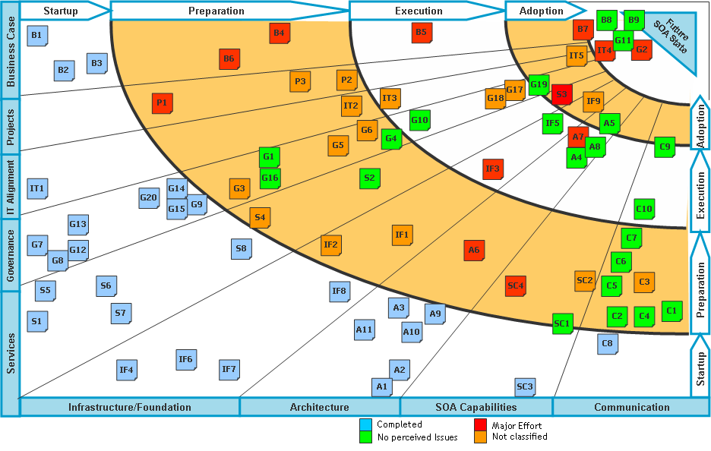

Figure 26: Sample Roadmap- Future SOA state

The timeline (across the top) can be done in phases or it could be done using time (months or years).

The roadmap is broken out into the following categories:

* Business Case (if necessary): the activities needed to cost-justify the overall effort
* Projects: a set of potential projects that could be done using SOA
* IT Alignment: the activities needed to align IT to the business
* Governance: the activities needed to put the SOA Governance model in place and begin executing upon it
* Services: the activities needed to build out additional reusable services
* Infrastructure foundation: the activities needed to put the hardware, network, execution and monitoring software in place.
* Architecture: the activities needed to put the SOK’s newly adopted EA framework standards and design patterns in place.
* SOA Capabilities: the activities needed to support SOA within the SOK’s lines of businesses, including hiring of the necessary resources, training, educating business and IT resources on SOA and SOE Concepts.

Communication: the activities needed to keep the lines of businesses in SOK aware of the progress being made in the effort to move to an SOA.



Figure 27: Overall Project Process

**Tools, Accelerators & Best Practices**

1. Integration Patterns

2. Real Time

3. Batch Integration Design Principles

### Key Tools, Accelerators and Best Practices

#### Capgemini Integration Design Principles based on Industry Standards and Best Practices - RealTime

|  |  |
| --- | --- |
| Principle | Description |
| Online-Data Access instead of Data Replication | Instead of the Replication of Business data between the leading systems, , the online data (either directly from the leading system or in an online data storage) should be called |
| Access (Authentication and authorization of the Application Level) regulated by the client | Service based integration where The access to sensible data is administered by central client Infrastructure for Identity- & Access-Management. |
| VETO and VETRO | VETO is a common integration pattern that stands for Validate, Enrich, Transform, Operate. It has many variations, one such variation is VETRO pattern which includes a "Route" step. The VETO and VETRO patterns can ensure that consistent, validated data will be routed throughout the ESB |
| Canonical Data Model | Canonical Data Model minimizes dependencies when integrating applications that use different data formats. Consumers should use it when invoking services exposed on the ESB. |
| Request Response | Request/Response should be used when real time synchronous response from provider is required and the transaction processing time required by the provider is not significant. |
| One Way Message | One Way Message returns asynchronous response from the provider and should be used when the transaction processing time required by the provider is significant. |

#### Capgemini Integration Design Principles based on Industry Standards and Best Practices - Batch

| Principle | Description |
| --- | --- |
| Online- instead of Batch-Processing | The standard software must offer simple operating and comprehensive Online Interfaces. Online- should be used instead of Batch-Integration at the places, where it is possible and reasonable. Ideally Batch interfaces and batch processing are used only if the underlying business requires them |
| Online-Data Access instead of Data Replication | Instead of the Replication of Business data between the leading system for business data and systems, which they use, the online data (either directly from the leading system or in an online data storage) should be called. |
| Batch Exchange of Master- and transaction data with data hubs (Hubs) | In the batch – processing, Master- and dynamic data should be exchanged with a consolidated data hub |
| Writing access to persistent data with the Application-Cluster-Limit only on interfaces | There is no direct writing access to the data of other Application Cluster. The writing access to persistent data in another application cluster takes place through calling an interface of this application cluster. The interface is responsible for the maintenance of the data consistency |
| Access (Authentication and authorization of the Application Level) regulated by the client | service based integration where The access to sensible data is administered by central client Infrastructure for Identity- & Access-Management |

#### Accelerators

Integration Architecture Framework

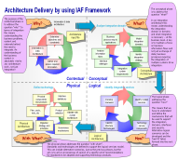

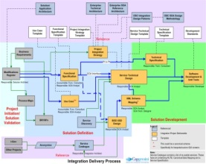We have found that using an Enterprise Architecture framework provides a common language for the business, IT, partners and suppliers to communicate the business needs and drivers needed to deliver IT requirements. This does not only deliver the business functionality but ensures that the non-functional requirements are identified to deliver the services by defining the required service levels, including availability, performance, resilience of the systems and applications, and inform the infrastructure provider of the service levels required from the infrastructure components.

SOA Rapid Start

The SOA Rapid Start provides a standard delivery methodology for SOA based implementations and defines the phases, tasks and deliverables together with templates and accelerators for each phase.

Design Templates, Guide Lines and Best Practices

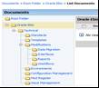Capgemini has developed design templates for the components of the Middleware Product stack and is used as the starting point for customizing them to the project specific requirements thus reducing the cycle time for approval of the design templates. Capgemini has also developed Design guide lines and follow industry best practices which help is developing an efficient and optimized solution.

Integration Patterns and Reference Architecture

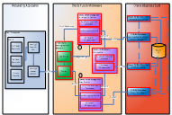Based on the expertise on the Middleware Product and our implementation experience Capgemini has developed the Reference Implementation Architecture and Best Practices for Middleware Solution. There are pre-designed integration patterns with prototypes available in our repository to jump-start SOA design and development.

KM Portal

****The Capgemini KM portal is the primary knowledge repository for consulting services artifacts. One of many artifacts in our repository we leverage for SOK as an example is cutover plans that will serve as a template for developing and executing the cutover plan for the implementation of wave of the program.

#### Tools

Checkstyle:

Checkstyle is a free and open source development tool that helps to ensure that your Java code conforms to the coding conventions you've established. It automates the crucial task of checking Java code. Checkstyle is often used as an Eclipse plugin, and also as part of a project build to create a report of coding-standard violations. It can be used in conjunction with build tools such as Ant or Maven. Checkstyle provides many readymade standard coding rules, which are very useful. The rules can also be customized by adding new rules, editing the existing rules or removing the rules

CAST / Application Intelligence Centre (AIC)



Figure 28: Application Intelligence Centre

CAST is an Application Analysis tool used to assess various health factors and quality indicators and provides a list of code metrics that will be used in a computation of the maintainability index. The tool is used selectively on identified problem applications after the authorization from our client. Using CAST can facilitate improvement in the quality performance of applications and offer key productivity benefits which enable Daimler to stick to the Rollout duration

Volatility Analyser

Volatility Analyser is an in-house developed component by Capgemini. It identifies a list of volatile components. Volatile components are the ones which have either:

* Undergone lot of changes, since they are unstable
* Undergone lot of changes, since they are complex

Undergone lot of changes, since they are having core logic of the application

It scans the code base of any technology, it parses the code base for various date patterns in the comments. Based on the number of occurrences of dates identifies the volatile components. It can used to identify the highly volatile components. It can be used during transition and the identified volatile components can be targeted for code walkthroughs with SMEs.

|  | Change # | | | | | |  |
| --- | --- | --- | --- | --- | --- | --- | --- |
| File Name | 2007 | 2008 | 2009 | 2010 | 2011 | Grand Total | LOC |
| RecapUtil.java | 239 | 105 | 248 | 76 | 37 | 705 | 14584 |
| BPDHelper.java | 108 | 35 | 100 | 70 | 23 | 336 | 11468 |
| PDFDataGenerator.java | 3 | 77 | 127 | 130 | 56 | 393 | 10697 |
| BookingDataHolder.java | 80 | 85 | 92 | 50 | 30 | 337 | 9514 |
| EuronetStatelessFacadeBean.java | 19 | 63 | 33 | 24 | 3 | 142 | 8862 |
| PaymentCreditCardPane.java | 106 | 184 | 209 | 204 | 2 | 705 | 7423 |
| RECRecapUtil.java | 15 | 38 | 54 | 63 | 10 | 180 | 7170 |
| BookingProductModel.java | 54 | 22 | 46 | 30 | 12 | 164 | 6781 |
| AfsPaymentReimbursementModel.java | 72 | 86 | 74 |  |  | 232 | 6593 |
| PTPPackageResultsPane.java |  |  | 99 | 45 | 18 | 162 | 5852 |
| AfterSalesUtility.java | 19 | 75 | 60 | 10 | 4 | 168 | 5787 |
| ResarailDialog.java | 12 | 3 | 144 | 1 |  | 160 | 5395 |
| AfsUtil.java | 5 | 69 | 87 |  | 6 | 167 | 5322 |
| BookingProductPane.java | 11 | 35 | 102 | 33 | 34 | 215 | 5169 |
| PTPAllFrameController.java | 67 | 20 | 87 | 36 | 12 | 222 | 5121 |
| AfterSalesExchngResaRailController.java | 142 | 8 | 20 |  | 40 | 210 | 5009 |
| PTPDBHelper.java | 14 | 10 | 40 | 42 | 16 | 122 | 5007 |
| BookingFrameModel.java | 29 | 40 | 95 | 46 | 4 | 214 | 4770 |
| PTPSchedulesPane.java |  |  | 78 | 20 | 14 | 112 | 4341 |
| PTPUtility.java | 10 | 4 | 20 | 39 | 28 | 101 | 4188 |
| PTPFareResultsModel.java | 22 | 30 | 28 | 16 | 10 | 106 | 4118 |
| AmtrakWSUtility.java | 2 |  | 84 | 46 |  | 132 | 4005 |
| PTPPriceSearchPane.java |  |  | 116 | 78 | 18 | 212 | 3691 |
| REGUtil.java | 32 | 30 | 35 | 5 |  | 102 | 3659 |
| PTPIndivPaxAssignModel.java | 84 |  | 96 | 8 | 12 | 200 | 3527 |
| AfsTicketInfoModel.java | 14 | 24 | 33 | 19 | 19 | 109 | 3525 |
| PTPPackageResultsModel.java | 2 |  | 46 | 62 | 18 | 128 | 3499 |
| PTPSchedulesModel.java | 4 |  | 116 | 22 |  | 142 | 3467 |
| PTPRecapPane.java | 38 | 6 | 54 | 2 |  | 100 | 3323 |
| PaymentDataHolder.java | 16 | 106 | 112 | 12 |  | 246 | 3301 |
| BO_BookingPayment.java | 26 | 90 | 63 | 14 |  | 193 | 3291 |
| BO_AfterSaleTransMgr.java | 18 | 34 | 52 | 24 |  | 128 | 3290 |
| PTPIndivPaxAssignPane.java | 57 |  | 56 | 32 |  | 145 | 3077 |
| ItineraryController.java |  | 2 | 28 | 44 | 27 | 101 | 3025 |
| PTPSearchPane.java | 8 |  | 75 | 24 | 15 | 122 | 2804 |
| BookingShippingPane.java | 26 | 94 | 39 | 6 | 8 | 173 | 2731 |
| PAHBookingRecapFormatter.java | 1 |  | 47 | 67 | 8 | 123 | 2665 |
| BookingNavigationPane.java | 37 | 19 | 56 | 40 | 18 | 170 | 2650 |
| ConsumerInfoPane.java | 18 | 74 | 64 | 4 |  | 160 | 2455 |
| PaxPane.java | 27 | 6 | 90 | 47 |  | 170 | 2437 |
| PaymentController.java | 10 | 81 | 8 | 2 |  | 101 | 2345 |
| BookingFrameController.java | 34 | 40 | 34 | 7 | 6 | 121 | 2278 |
| REGDateFormat.java | 28 | 13 | 57 |  | 2 | 100 | 2221 |
| PaymentSelectionModel.java | 5 | 70 | 109 |  |  | 184 | 2206 |
| BookingRecapFormatter.java | 51 | 41 | 42 | 32 | 8 | 174 | 2189 |
| PassAssignmentModel.java | 2 | 4 | 108 | 12 |  | 126 | 2114 |
| MsgConstants.java | 14 | 44 | 58 | 24 | 6 | 146 | 2018 |

Top 47 components: Selection criteria for Large LOC >= 2000 and Number of changes(Volatile) >= 100

## Assumptions & Dependencies

Capgemini has listed our assumptions based on our proposed solution:

* EAI related monitoring will be provided by SOK and tickets will be moved with SD2SD integration
* SD2SD integration will be implemented during transition project
* All relevant service documentation is assumed to exist in English language and all new documentation is created in English
* Infrastructure vendor service desk is available for monitoring and escalations 24/7
* Knowledge transfer and operational support activities communication will be in English.
* In-flight projects – any current in-flight projects are excluded from the solution and will be handled by an associated change order
* Test data will be provided by the customer.
* It will be SOK’s responsibility to provide live connectivity to external interfaces during development, system testing, functional testing, regression testing and UAT
* IBM has informed Capgemini that it is very likely that the existing production licenses SOK has bought would enable Capgemini to create a full blown development environment without any additional cost for SOK. With SOK’s permission Capgemini is currently investigating this option together with IBM. Since the investigation is not yet finished the price for the development environment(s) has not been provided.
* In order to decide the best test automation tool for SOK EAI Capgemini requires more detailed technical data on the environment and current test cases. As indicated by SOK these details are released in later stages of the negotiations, thus test automation is not priced.
  + Note: Based on the information currently available to Capgemini CA Lisa test automation tool seems to be the best solution.
* The test, staging and production environments will be provided by SOK.

**Specific Assumptions for Application Development**

* Application Development services will be provided during SOK business hours 8 hrs. - 16hrs. CET (Monday to Friday).

**Customer Obligation/Dependencies**

* SOK is to ensure the support from current vendors.
* Identification of key internal and key external stakeholders and providing timely access to them, resources and empowered decision makers as required
* Participating openly and collaboratively during workshops/meetings as required;
* Timely sign-off and acceptance of deliverables on completion of the project and as appropriate at each checkpoint
* Provide any updates to existing Business Continuity plans for Capgemini to update and amend to include the new services

## Governance



Figure 29: Governance Structure

Capgemini will implement a robust IT governance and service management structure between the service recipient and service providers (vendors) at the outset due to the level of failures that are attributed to governance issues. Getting the governance right during the early phase of the outsourcing activity is a critical success factor. This is because it will ensure the necessary behaviours between the sourcing parties and deliver value for the duration of the relationship.

# Transition Approach

#### Capgemini Global Transition Methodology

The SOK EAI Transition would be carried out using the Capgemini Global Transition Methodology. Capgemini will propose a transition phase between Capgemini, SOK and the current incumbent providers for the appropriate service takeover and knowledge acquisition of the integrations, development and testing processes in scope. This would cover the functional, technical, platform details, process and Tools employed. Capgemini understands that it is fundamental to SOK that Capgemini’s approach to transition of the services in scope is comprehensive, low risk, secure and disruption free.

Capgemini Global Transition Methodology Standard in Deliver™ has 4 phases (Start-up, Execution, Handover and Close Down) and 7 streams which help navigate more quickly to the range of activities normally applicable at a given point in time. Capgemini will deploy our standard Deliver™ transition methodology and tools to execute the transition. The figure below highlights the 7 streams of the Capgemini Transition Methodology. As is evident from the schematic, the transition would be carried out in a collaborative manner and the Capgemini team would clearly call out the specific areas where they would need the assistance of the SOK SPOCs. The seven streams would be covered in detail in section 6.2

***Capgemini Transition Methodology***

1. **Best Practices from 100+ Transitions**
2. **Tools Driven**
3. **Disruption Free**

***4.* High Collaboration**

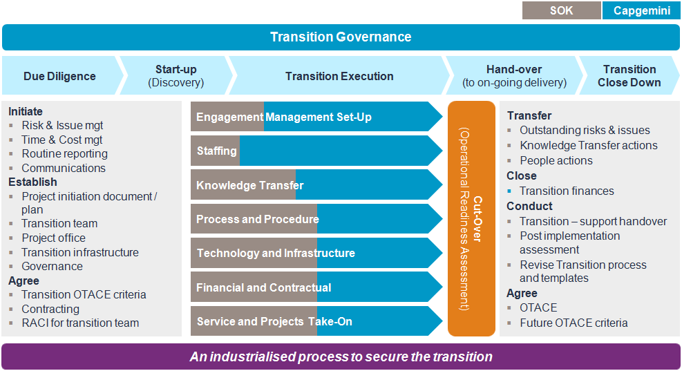

Figure 30: Capgemini Global Transition Methodology

Below shows Capgemini elaboration of transition principles and the basis for transition approach

* **Smooth, secure and effective transfer of in scope services** - In order to ensure a smooth, secure and effective seamless handover, it is important to establish quality checks at key stages to assess the maturity and readiness of Capgemini to take-on the service
* **Focus on Knowledge Transfer:** - Capgemini will leverage its Knowledge transfer methodology and associated tools to ensure an effective knowledge transfer takes place. During the knowledge transfer phase, Capgemini will carry out remote sessions via Capgemini’s tried and tested tools and in some cases send its team to the SOK and incumbent vendor Office sites. This will facilitate a deep understanding of the business. This will also help to better understand the criticality of the integrations towards the business. This internal vision will allow the team to provide the services by being better prepared.
* **Feasible and effective Transition Period:** - Based on the integrations criticality, stability, vendor support, ticketing volumes and other parameters, Capgemini has devised a transition timeline that would ensure a seamless takeover of services in scope. The transition will be managed by a dedicated, experienced transition team which specializes in carrying out transitions.
* **Seamless transition of responsibility for the provision of services** - Capgemini recommends that the transition project framework is reviewed in detail from the planning phase to give SOK a leading view on the key dependencies and risks associated with the project. This will give Capgemini and SOK, the opportunity to focus on refinement and adjustment of Capgemini’s individual plans in view of the key business cycle, associated dependencies and risks towards business
* **Clear Process, Methods and work instructions** - Capgemini will run the transition phase with clear set of processes, methods and work instructions. These processes, templates and work instructions are built on a proven and industrialized framework leveraging several large Capgemini transitions.

## Scope of Services

This section presents Capgemini’s understanding of the scope of transition of services from SOK and the incumbent suppliers to Capgemini. We have designed the transition solution for SOK taking into consideration the requirements stated in RFP and our extensive experience of successfully transferring services.

The scope of services under Application Management will include Bug Fixes, Enhancements and Related Testing. These will be assigned to the ADM team as Change requests.

This will include

* Implementation of new integration, changes to existing integrations, other modification (termed as modification work)
* Work requests to perform, change or delete integrations and data flows.
* Correction of Integration errors (event management) and finding out the root cause of Integration problems and solving (problem management) them in co-operation with other business suppliers (responsible for coordinating)

The scope of services under Infrastructure Management will include EAI Support primarily covering the below:-

* Maintenance of Integration Service (Control & Managing)
* Maintenance of EAI Service desk/Service Desk
* IBM Datapower support

## Transition Plan for SOK

Based on the services scope defined in the RFP, Capgemini proposes an 8 weeks period for the service transition. During this period Capgemini would engage with SOK and the incumbent vendors to get the necessary knowledge on the integrations and applications setup the connectivity, accesses and processes and agree on the future service delivery mechanisms.

The **SOK transition** plan is placed below along with a description of the key features of the transition phase and key streams for this phase.

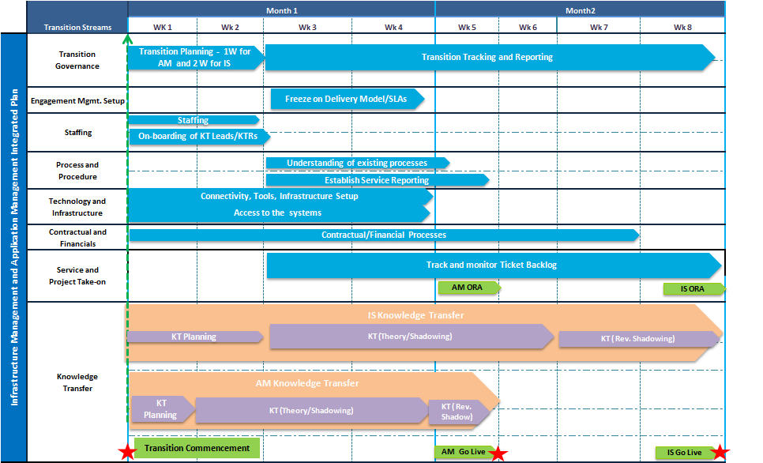

Figure 31: Stream-wise Transition approach for SOK

**Key Features:**

* The above transition approach has been defined in accordance with Capgemini Global Transition Methodology
* Capgemini will appoint a Transition Manager who would oversee the Infrastructure & Application Transition Planning, execution and handover of the In-Scope Services and would collaborate with all the stakeholders involved for successful service takeover.Capgemini proposes 2 key milestones for the transition.
* Transition Planning Completion – At the end of Week 2, Capgemini would have gathered the critical documentation and built the Knowledge Acquisition Plans to facilitate the Knowledge Transfer and initiated the first level Knowledge Transfer process
* Transition Completion – At the end of Week 8, the transition would be completed after reverse shadowing and Operational Readiness Assessment is conducted between Capgemini and SOK
* Capgemini would put in place Governance models and processes to ensure the transition is managed in an effective, transparent and risk free manner
* Detailed Project Governance Plan will be agreed with SOK approval. The Transition Project Governance Plan (PGP) will provide details of the governance framework within which the transition will operate and report weekly. This will ensure that the transition progresses smoothly and achieves the required objective of enabling services to transfer to Capgemini with minimum risk.

PGP also ensures that key deliverables and processes are agreed upon, including

* Scope of service
* Transition Governance structure and model
* Plans and Schedules
* Acceptance Criteria and Procedure for Signoff
* Meeting Structure
* Reporting formats and Communication management
* Risk and Issue Management
* Roles and Responsibilities / Escalation procedure
* Detailed Transition Plan will be agreed with SOK for approval
* Detailed Knowledge Transfer plan with Schedule will be shared with SOK for approval
* Comprehensive Documentation Analysis will be done
* Connectivity and access requirements would be gathered and processes would be setup to get all required accesses
* Current Process and Procedures analysis would be done and process trainings would be carried out for the Capgemini resources The following common work streams associated with transition run in parallel to ensure a seamless transition execution:

***SOK Transition Plan***

1. **Milestone Driven**
2. **Defined through Project Governance Plan**
3. **Service Takeover post joint readiness assessment**

The 7 Streams of Transition and the associated activities with each stream are highlighted in the table below

| Stream | Activities |
| --- | --- |
| Transition Governance | Overseeing overall execution of transition  Status Reporting to SOK on weekly Status Reports & Risk and Issue Handling  Transition Planning – Defining OTACE Criteria, Transition Acceptance Criteria, Project Governance Plan creation |
| Engagement Management Setup | Produce Service Governance Manual /Service Quality Plan  Service Level Agreement Implementation, Tracking and Reporting |
| Staffing | Analysis of the Skill requirements necessary to support the services  Capgemini to staff the resources with the right skill set  Training arrangements for any skill gaps identified |
| Technology and Infrastructure | Verification of Network Connectivity requirements from Capgemini  Procurement of SOK Cards for access to systems  Access to Tools, Applications and Development Environments |
| Process and Procedures | Study and understand current processes  Conduct Process Trainings |
| Knowledge Transfer (KT) | Knowledge Transfer to be carried out for the different integration types – Message, File, Service, Direct, SAP and ETL based Integrations  The Knowledge Transfer would be planned for incidents, change requests and bug fix related activities  Capgemini Transition Manager and KT Leads would carry out the Knowledge Transfer planning with inputs from the incumbent vendor (SME’s) and client SMEs. This will lead to creation of Knowledge Acquisition Plans (KAP) for each application and would be signed off by SOK SPOCs  Knowledge Transfer Execution would include sessions with the incumbent vendor Subject Matter Experts and relevant SOK experts on Architecture Design, functionalities, development processes and testing activities  Detailed Knowledge Transfer approach is provided in Section 6.3 |
| Financial & Contractual / Vendor Management | Establish financial reporting mechanism  Management of any Scope Changes |
| Service and Project Taken-on | Operation Readiness Assessment with the internal and client stakeholders before takeover of services  Assessment and takeover of in-flight projects |

**Operational Readiness Assessment (ORA) and Hand over**

Capgemini would carry out a detailed Readiness Assessment before taking over the ownership of services towards the end of transition. Capgemini would leverage its standardized checklists and processes to ensure that all the pre-requisites for service takeover are in place. The following activities will be carried out in the Operational Readiness Assessment and Handover phase:

* Knowledge Transfer Sign off (Based on KT Acceptance Criteria) – This would be done at the end of the Knowledge Transfer phase. Capgemini resources would provide playback sessions to the SOK and incumbent vendor representatives and display their understanding of the integrations and systems in scope.
* Service Operational Readiness Assessment (Testing of Services Readiness) based on Transition Acceptance Criteria
* **Connectivity and Access to Environments** - The Capgemini transition team would prepare a detailed Access Tracker where the accesses required by the different Capgemini resources would be listed and the access status would be checked. Prior to go live, Capgemini would ensure that all accesses, development and testing environments are set-up. This would be the key focus of the Technology and Infrastructure stream.
* **Process, Procedures and Tools** –Capgemini would ensure that prior to go live, all resources have the access to the Service Management Tool (BMC Remedy). Capgemini would also seek inputs and sessions from SOK for process trainings to the resources so we have an end to end view of the current workflow, practices and communication mechanisms. The understanding from these sessions would be documented and submitted to SOK for review.

Operational Readiness Assessment would ensure that the Knowledge has been transferred completely and accurately, the connectivity and accesses are in place, all the outstanding risks have been mitigated, the processes have been set-up and trainings have been done and decisions have been taken for takeover of inflight projects and any backlog of incidents or change requests. At the end of the assessment, decision would be taken mutually to handover the delivery of services to Capgemini

## Focus on Transition stream: Knowledge Transfer

The objective of knowledge transfer exercise is to ensure smooth transfer of knowledge from the current supplier / SOK on the current transversal services in scope. The knowledge transfer process will follow Capgemini standard knowledge transfer methodology

Below is the knowledge transfer mechanism

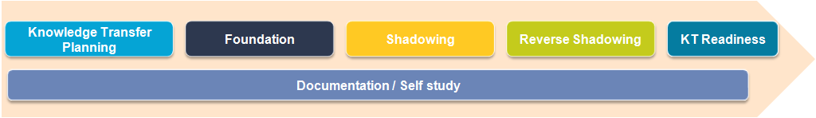

Figure 32: Knowledge Transfer Phases

***Knowledge Transfer***

1. **Tracking through Transition Portal**
2. **Assessment through Playback Sessions and Application Overview Document Review**
3. **Leverage Accelerators**

Table below provides a brief overview of each phase,

| Phases | Short Description |
| --- | --- |
| **Knowledge Transfer Planning** | Phase during which the knowledge transfer approach for each application/integration type in scope. The activities are detailed out and knowledge acquisition plan prepared |
| **Foundation** | Phase during which Capgemini resource acquires knowledge from the SOK or incumbent vendor Subject Matter Experts on business processes / application characteristics, architecture design, development and testing processes and service requirements based on the knowledge acquisition plan |
| **Shadowing** | Capgemini personnel will observe and document the daily activities performed by current delivery personnel (Subject Matter Expert). This would also include a walkthrough of some of the critical current and past incidents, service and change requests |
| **Reverse Shadowing** | Gain Hands-on experience on the service. Capgemini resources would execute incidents and service requests under the supervision of the SMEs. This will provide a valuable view of the end to end process before service takeover. |
| **KT Assessment** | Frameworks to measure knowledge gained by Capgemini personnel and assess readiness to deliver the service. This will be done in the form of playback sessions and assessing the performance during reverse shadow |
| **Documentation / Self Study** | Study the existing documentation to gain first-hand knowledge on the application. Update documentation associated with the application based on the knowledge gained via self-study and knowledge sharing sessions |

**Knowledge Transfer Tracking**

The progress of the entire knowledge transfer session by session, can be viewed on the online transition portal (Online Knowledge Transfer Progress Tracker) where the Knowledge Acquisition Plan would be uploaded.

SOK management will be given access to this tool. The Transition Portal provides transparency to the entire knowledge transfer execution process. A number of reports are available on the portal, like for example reports on knowledge transfer effectiveness and Capgemini’s autonomy levels for handling change requests. The transition portal also provides key metrics and KPIs for tracking each phase of knowledge transfer.

Feedback for every session is captured from both SMEs and Capgemini’s knowledge transfer recipient to derive metrics that provide a measure of effectiveness of the knowledge transfer session. Hence, if knowledge transfer sessions are not to expected quality, this is brought to notice on the portal and the Capgemini Transition Team will focus on these knowledge areas to ascertain how the knowledge gaps can be resolved.

**Knowledge Transfer Assessment**

Throughout the knowledge transfer phase there will be checks and balances in place to not only ensure we are on track but also measure our readiness in terms of the assimilation of knowledge shared during KT sessions. Listed below are our measures to ensure readiness:

1. **Playback sessions:**

Towards the end of the Foundation KT phase, the KT recipient will demonstrate back to the SME his understanding of the critical areas of the application. This is a mechanism to validate if the accuracy of the knowledge gathered by the KT recipient and also allows for fine tuning of information.

1. **Knowledge gap in attainment levels**

The knowledge acquisition plan has the attainment levels defined by the SME. During the course of the KT the recipient has to provide his feedback on the attainment level per topic / session. The transition portal identifies any knowledge gap and this acts as an input to focus on select topics which need more attention or SME input. This mechanism will ensure that the KT recipient is comfortable with the knowledge acquired and demonstrate his confidence in taking over the support.

1. **Application Overview Document Review**

During the course of transition, knowledge transfer recipients from Capgemini will prepare an Application Overview document which will entail the understanding that they have received during knowledge transfer. The document will be subjected to Subject Matter Expert review and will help in assessing the knowledge received by Capgemini staff

## Transition Accelerators

Capgemini will use the following tools during Transition to expedite the transition planning and execution:

Transition Portal

This is an internal Capgemini Portal specifically developed for Transition which helps in overall Transition execution and knowledge transfer.

The progress of the entire knowledge transfer for each application, session by session, can be viewed on the online transition portal (Online Knowledge Transfer Progress Tracker) where the Knowledge Acquisition Plan would be uploaded.

SOK key stakeholders will be given access to this tool. The Transition Portal provides transparency to the entire knowledge transfer execution process. A number of reports are available on the portal for SOK Reference.

Feedback for every session is captured from both SMEs and Capgemini’s knowledge transfer recipient to derive metrics that provide a measure of effectiveness of the knowledge transfer session. Hence, if knowledge transfer sessions are not to expected quality, this is brought to notice on the portal and the Capgemini Transition Team will focus on these knowledge areas to ascertain how the knowledge gaps can be resolved

CAST Application Intelligence Platform

CAST AIP (Application Intelligence Platform) is a proven tool that helps to identify potential problem areas in the applications proactively by spotting the architectural and code issues.

The CAST AIP audits application source code against industry standards and best practices, and captures a subroutine-level mapping of the systems landscape. It is like having thousands of code-reviewers who are collectively aware of how each piece of new code interacts with the rest of the system. The CAST AIP analyses complex software applications and automatically provides the metrics and information needed to measure, control and improve the health of business systems and the performance of development teams around the globe.

Capgemini will use CAST AIP to carry out the code base analysis during the transition and jointly draw up an improvement plan to increase the robustness of the system during the steady state.

Microsoft Live Meeting

Live meeting is a tool used to share voice and screen to facilitate Remote Knowledge Transfer and to also to keep a record of the session for future reference. The tools helps in optimization of costs related to knowledge transfer. Supplier will use this tool extensively for the knowledge transfer process associated with each service.

## Key Assumptions

**Transition Governance:**

* SOK Transition Manager will engage the SOK SMEs and third party vendors / existing vendors during Transition Phase as per the Transition plan agreed. Impact of deviation from the agreed plan on cost/time will be evaluated
* Capgemini assumes a 2 week transition planning phase prior to the start of the execution for connect with Subject Matter experts, documentation study and assessment and developing the Knowledge Acquisition Plans
* Additional stream specific experts like process, connectivity etc. will be bought in from both sides to manage & execute the planned activities

SOK will ensure that all relevant SOK and third parties resources fully participate in transition activities as identified in the approved transition plan. All costs for third party participation will be met by the third party or the client.

**Knowledge Transfer:**

* Knowledge Transfer sessions would be planned for 3 hours a day. All required SOK and incumbent vendor SMEs would be available for the sessions scheduled
* The locations for Knowledge Transfer are assumed to be Finland & India. The KT would be both face to face and remotely via live meeting
* All support documents should exist and be in English. The documentation should be most updated
* All the supporting documentation should be shared with Capgemini, during the planning phase.
* No cost & effort for creation or translation of documents has been accounted for in transition.

All the KT sessions will in English and be recorded & SOK shall be responsible to get the SME’s consent for the same. Windows live meeting will be used for the KT sessions recordings.

**Technology and Infrastructure:**

* SOK Cards to connect to SOK systems should be made available to all resources within **2 weeks of the transition start.**

SOK will ensure adequate office space, desks, PC equipment and software plus sufficient system access for transition staff as reasonably required during Planning & Transition duration (at both KT locations) at no cost to Capgemini.

**Process and Procedures:**

Current SOK Service Management tools will be leveraged to deliver the services from Capgemini.

**Services and Projects Take-on**

* SOK to ensure all the open/pending change requests are closed before end of transition

Capgemini and SOK would carry out an assessment of the In-flight projects during the transition and jointly decide on the projects to be taken over by Capgemini. The Knowledge Transfer on these projects would be done separately and is not in scope of this transition

## Risks and Mitigation

| Issue/Risk Description | Mitigation Action |
| --- | --- |

|  |  |
| --- | --- |
| **Insufficient availability of key SOK/incumbent vendor SME’s during the transition period** | * Joint planning for the transition and clear communication on the resources needed * Identify the single point of contacts from incumbent suppliers for transition * Establish escalation channels and obtain management buy-in for the transition |
| **Loss of knowledge due to unavailability/ inability on the part of the incumbent key resources to conduct knowledge transfer. This would impact both quality and duration of KT** | * Ensure beforehand the availability of the Subject Matter Experts to do Knowledge Transfer * Identification of secondary SMEs in the event primary SMEs are unavailable due to work load or sickness |
| **Inadequate or outdated documentation would impact self-study by Capgemini resources. It would also lead to Capgemini resources spending lot of additional time on documentation updation** | * Conduct Document assessment reviews during initial stages of planning * Arrange for any necessary updates to the documentation if required * Use of appropriate KT techniques and tools so as to capture most of the knowledge during KT phase |
| **Delay in connectivity implementation and access to required environments & applications would delay takeover of services** | * SOK and Capgemini to assign a SPOC accountable for connectivity provisioning responsibilities at the start of the planning phase |
| **Restriction on usage of Transition tools or recording of KT sessions would hinder efficient Transition Management** | * Subject matter experts to ensure that all knowledge to be captured via documentation during Knowledge Transfer * Capgemini resources to update the Application Overview Documents on a daily basis to capture all the updates |

## 

## Transition Roles & Responsibilities

Table below provides a detailed list of activities per transition stream and associated responsibilities(R-Responsible, A- Accountable, C- Consulted, I- Informed) between Capgemini, SOK and current incumbent vendor. Only key roles have been listed. The RACI will be further refined during the initialization phase.

| *(A=Accountable, R= Responsible, I=Informed, C=Consult)* | Capgemini | | | SOK | Incumbent Vendor |
| --- | --- | --- | --- | --- | --- |
|  | Service Managers | KT Recipients | Transition Manager | Transition Manager | SMEs |
| **Transition Governance** |  |  |  |  |  |
| Conduct Initial Planning exercises with SOK | R | I | A | R |  |
| Conduct Kick-off Meeting | R | I | A/R | R | - |
| Develop and Agree Project Governance Plan | C | - | A/R | R | - |
| Develop and Agree Transition Project Plan | C | I | A/R | R | I |
| Setup Routine Reporting / Team meetings | C | I | A/R | I | - |
| Create Risk & Issue Register | C | I | A/R | C | I |
| Setup Transition Project OTACE | C | - | A/R | C | - |
| Setup Transition Acceptance Criteria | C | I | A/R | R | I |
| **Engagement Management & Delivery Initiation** |  |  |  |  |  |
| Establish scope of service(s) to be transitioned | A | - | R | R | C |
| Establish Service Reporting Requirement | A/R | - | C/I | C | - |
| Define Transition Roles & Responsibilities | C | I | A/R | C | I |
| Define Service Delivery Roles & Responsibilities | A/R | I | C | C | - |
| Establish routine Delivery meeting requirements | A/R | I | I | C | - |
| Prepare Service Delivery Model | A/R | - | C | - | - |
| Create Service Quality Plan | A/R | C | C |  | - |
| **Technology & Infrastructure** |  |  |  |  |  |
| Evaluate Bandwidth Requirements for Service Delivery | C | C | A | C | C |
| Increase the bandwidth | C | I | A | I | I |
| Evaluate usage of Tools and reuse of Licenses | C | I | A | R | - |
| Setup physical infrastructure (For Service Delivery) | R | I | A | C | C |
| Establish Access for Capgemini support team members | R | C | A | R | C |
| **Staffing** |  |  |  |  |  |
| Creation of Staffing Tracker | C | - | A | I | - |
| Evaluate Details Skill requirements | C | - | A | I | C |
| Initiate staffing of Capgemini staff | C | - | A | I | - |
| Project Induction & On boarding (For Service Delivery) | C | C | A | I | - |
| Team Training on Tools/Technical/Functional/Soft Skills | C | C | A | I | - |
| Skill Gap analysis | C | C | A | I | - |
| Team Mobility and Travel Planning | C | C | A | I | - |
| **Knowledge Transfer** |  |  |  |  |  |
| Establish Criteria for KT Success | C | I | A | C | I |
| Prepare KT Plan | C | C | A | C | C |
| Identification Of SMEs to participate in KT | I | I | A | A/R | I |
| Prepare Knowledge Acquisition Plans | C | C | A | C | R |
| Documentation Gap Analysis | A | R | A | I | C |
| Prepare templates to be used during KT | I | C | A | I | I |
| Setting up of knowledge repository | C | I | A | I | I |
| Collection and Upload of all available documentation onto Repository | I | I | I | A | R |
| Knowledge Transfer Execution | C | R | A | R | R |
| Operational Readiness Testing (1 Week before Go Live) | A | C | A | C | C |
| Knowledge Transfer Signoff | C | C | A | R | C |
| **Process and Procedures** |  |  |  |  |  |
| Define and agree Processes for service delivery | R | I | A | C | - |
| Configure process in Service Management tool | R | C | A | C | C |
| Setup Team Contact Lists & Communication Processes | R | C | A | C | C |
| Financial and Contractual Issues |  |  |  |  |  |
| Establish Financial reporting and invoicing | R | - | A | C | - |
| Assessment of 3rd party obligations | R | - | A | C | - |
| **Services & Project Take on** |  |  |  |  |  |
| Identify backlog & agree on responsibility | C | C | A | R | C |
| Document open issues and risks and agree on completion dates | C | C | A/R | C | - |
| Review and confirm handover Checklist completed for all items | C | C | A/R | C | - |
| All deliverables and documentation posted to shared repository | I | R | A | I | - |
| Transition Signoff | C | C | A/R | R | C |
| OTACE Assessment | I | I | A/R | C | - |

## 

## Reporting and Meeting Structure

| Meeting | Purpose | Key Attendees | Frequency |
| --- | --- | --- | --- |
| **Transition Kick-off** | * Meeting to launch the transition phase. Key Agenda items are: * Overview of Transition Project * Team Overview * Transition Governance structure and operating model * Overview of Key timelines and milestones * Overview of transition processes * Transition Plan Signoff | Capgemini Transition Manager, Capgemini Service Delivery Manager SOK Transition Manager, SOK Project Sponsor | One Time |
| **Weekly Status Report** | * Meeting to communicate the transition status. Key Agenda items are: * Review of overall transition plan – Planned Vs. Actual * Detailed Knowledge transfer status * Review overall risks and issues and decide on mitigation actions * Discuss Escalations and recommendations to address the escalations * Status of Acceptance Criteria for Key Milestones * Review status of deliverables for each milestone * Key Changes / decisions that require approval and assistance from Steering Committee. | Capgemini Transition Manager, Capgemini Service Delivery Manager SOK Transition Manager, SOK Service Managers | Weekly |
| **Transition Steering Committee** | Key Agenda Items   * Transition progress status * Budget status * Outstanding Risks, Issues, Actions | Capgemini Transition Manager, Capgemini Service Delivery Manager SOK Transition Manager, SOK Project Sponsor | Fortnightly |
| **Transition Signoff Meeting** | Key Agenda Items   * Validate the end of the Transition phase - Operational Readiness Assessment Report discussion * Sign the cut-over to delivery: confirm that the Readiness Assessment has been satisfied, obtain written authorization from SOK to transfer the service responsibility to Capgemini | Capgemini Transition Manager, Capgemini Service Delivery Manager SOK Transition Manager, SOK Project Sponsor | One-Time |

# Pricing

Pricing is described in the Executive Summary.

## Price Categories Per Task

A mapping of the tasks (T&M - separately billable) given in Appendix 3 and the price categories in the agreed rate card are shown in the embedded document below:

| **Kategoria** | Palvelu | **Palveluaika N/E/F** | **Asiakas** | **Suunnittelu- ja Kehityspalvelut (Erillislaskutettava)** | **Ylläpitopalvelut  (Kiinteähintainen)** | **Infrastruktuuripalvelut** | **Toteutuksen tilaaja** | **Vuosivolyymi (max)** | **Suorittava rooli (S-ryhmän hinnaston kategoria, itse hinta määräytyy henkilön graden mukaan)** | **Kommentit / Palvelun laajuus** |
| --- | --- | --- | --- | --- | --- | --- | --- | --- | --- | --- |
| Vuosikellon mukainen toiminta | Arkkitehtuurin vuosihuolto: Integraatioarkkitehtuurin ja tiekartan säännöllinen päivitys | N | R | AR |  |  |  | 1 krt/vuosi | IT consultancy services | Kerran vuodessa, 3 työpajaa. |
| Ohjelmistojen versiotiekartan ylläpito | N | R | AR |  |  |  | 1 krt/vuosi | IT consultancy services | Kerran vuodessa. |
| Integraatioarkkitehtuurin tarvelähtöinen päivitys | N | R | AR |  |  |  |  | IT consultancy services | Tehdään tarvittaessa erillisestä tilauksesta. |
| Integraatiojärjestelmän ylläpito  (tuotanto- ja testiympäristöt) | Varusohjelmistot ja sovelluspalvelimet (DB2, HADR, WAS) | N | C | AR |  |  |  |  | IT consultancy services |  |
| Keskitetty integraatioratkaisu (MQ, Broker, iSuite DMZ, iSuite Hallintahub, Käyttöliittymä) | N | C | AR |  | R |  |  | IT consultancy services |  |
| Hajautettu integraatioratkaisu (iSuite Client: toimipaikka-adapterit) | N | C | AR |  |  | C |  | IT consultancy services | Tehdään yhdessä toimipaikka-adapterin palvelimen käyttöjärjestelmää operoivan tahon kanssa. |
| Hajautettu integraatioratkaisu (iSuite Client: sovellusadapterit) | N | I | AR |  |  | C |  | IT consultancy services | Tehdään yhdessä sovellusadapterin palvelimen käyttöjärjestelmää operoivan tahon kanssa. |
| Varusohjelmistot ja sovelluspalvelimet (DB2, HADR, WAS) | N |  | AR |  |  |  |  | IT consultancy services | Sovelluspalvelimen profiilit ja perusasetukset. Tietokannan asetukset. |
| Integraatioratkaisun käyttämät tietokantataulut ja indeksit. (kehitys ja testi)  Maintain database server and application server CI information in Capgemini CMBD | N |  | AR |  |  |  |  | IT consultancy services |  |
| Integraatioratkaisun käyttämät tietokantataulut ja indeksit. (tuotanto)  Maintain database server and application server CI information in Capgemini CMBD | N |  | AR |  |  |  |  | IT consultancy services |  |
| Keskitetty integraatioratkaisu (MQ, Broker, iSuite DMZ, iSuite Hallintahub, Käyttöliittymä) | N | C | AR |  | R |  |  | IT consultancy services | Esim. ohjaussäännöt, osapuolet, MQ-jonot, flowt, käyttöliittymäsovelluksen asetukset. |
| Hajautettu integraatioratkaisu (iSuite Client: toimipaikka-adapterit) | N | C | AR |  |  | C |  | IT consultancy services | Toimipaikka-adapterin konfiguraatio. |
| Hajautettu integraatioratkaisu (iSuite Client: sovellusadapterit) | N | I | AR |  |  | C |  | IT consultancy services | Sovellus-adapterin konfiguraatio. |
| Varusohjelmistot ja sovelluspalvelimet (DB2, HADR, WAS) | N | C | AR |  |  |  |  | IT consultancy services |  |
| Keskitetty integraatioratkaisu (MQ, Broker, iSuite DMZ, iSuite Hallintahub, Käyttöliittymä) | N | I | AR |  |  |  |  | IT consultancy services | Toimittaja vastaa Integraatioratkaisun komponenteissa olevien virheiden ongelmaselvityksestä. |
| Hajautettu integraatioratkaisu (iSuite Client: toimipaikka-adapterit) | N | I | AR |  |  | C |  | IT consultancy services |
| Hajautettu integraatioratkaisu (iSuite Client: sovellusadapterit) | N | I | AR |  |  | C |  | IT consultancy services |
| Tietosisältövirheiden ratkaisu | N |  | R |  |  | AR |  | IT consultancy services |  |
| Raportin laatiminen häiriöstä | N |  | AR |  | R |  |  | IT consultancy services | Laajavaikutteinen häiriö tai erikseen pyydettäessä. |
| Integraation ja alustan toteutus ja pienkehitys | Toteutuksen määrittely ja suunnittelu | N | C | R |  |  | AR |  | IT consultancy services |  |
| Projektinhallinta | N | C | R |  |  | AR |  | Project and Service Management | sisältää projektin jäsenten osallistumisen projektin johtamiseen kuten projektikokouksiin |
| Muutokset integraatioarkkitehtuuriin | N | A | R |  |  | C |  | IT consultancy services |  |
| Toteutus, moduulitestaus, kehitysaikainen virhekorjaus | N |  | AR |  |  | R |  | IT consultancy services |  |
| Toiminnallinen testaus | N |  | AR |  |  | R |  | Testing Services |  |
| Järjestelmätestaus (päästä päähän) | N |  | R |  |  | AR |  | Testing Services |  |
| Toteutuksen tuotantoon siirto, asennuspakettien valmistelu | N | I | AR |  |  | R |  | IT consultancy services |  |
| Laaduvarmistus | N |  | AR |  |  |  |  | Testing Services | Osana toteutusta tehtävä tarkempi laadunvarmistus (esim. koodikatselmointi, testaus). |
| Integraatioratkaisun laadunvarmistus (toteutuksen aikaiset yhteensopivuuskatselmoinnit ja prosessin mukaisen toiminnan varmistus) | N |  | AR |  |  |  |  | IT consultancy services | Varmistetaan, että Toimittajan tekemät projektien integraatiototeutukset on tehty prosessin mukaisesti (quality gatet) ja hyviä käytäntöjä noudattaen. |
| Suunnitteluun, toteutukseen ja tukipalveluihin liittyvä dokumentointi | N | C | AR | R | R |  |  | IT consultancy services |  |
| Varusohjemistot ja sovelluspalveliment | N | C | AR |  |  |  |  | IT consultancy services |  |
| Sovellukset | N |  | AR |  |  |  |  | IT consultancy services |  |

# Conditions

Please see appendix A - Liite 7 Sopimusta ja Transitiosopimusta koskevat keskeiset vaatimukset.docx.

# Key Indicative Profiles

Transition Manager

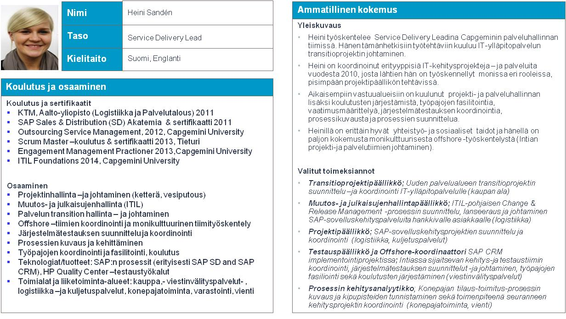

Senior Architect

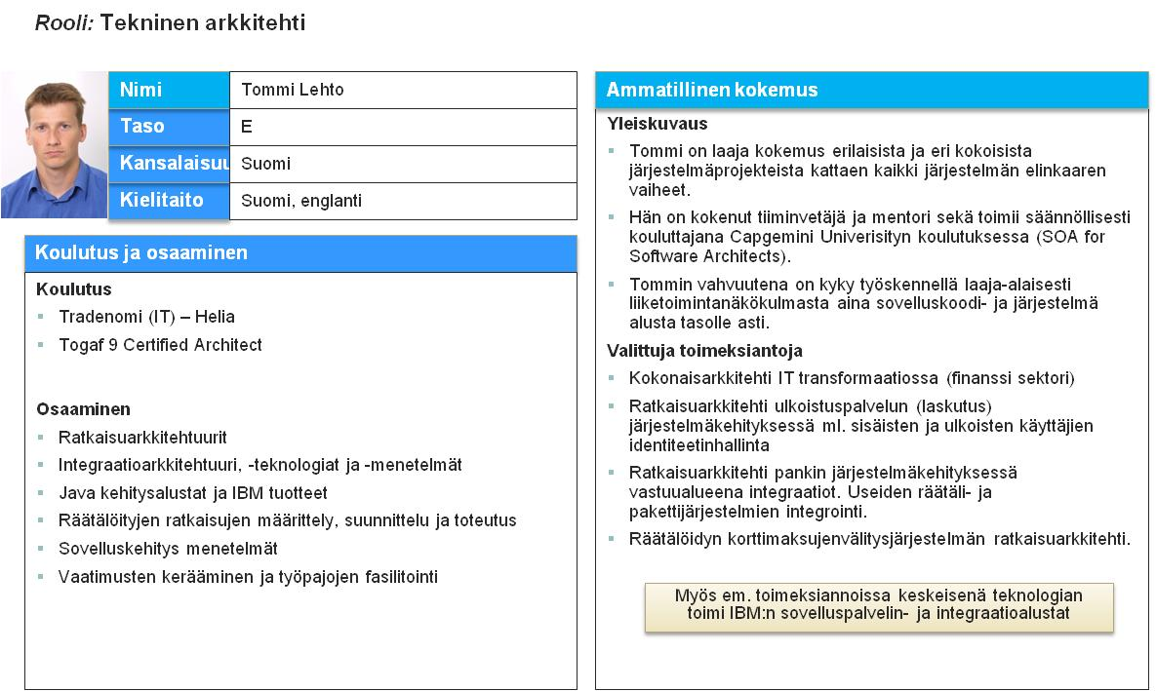

Architect

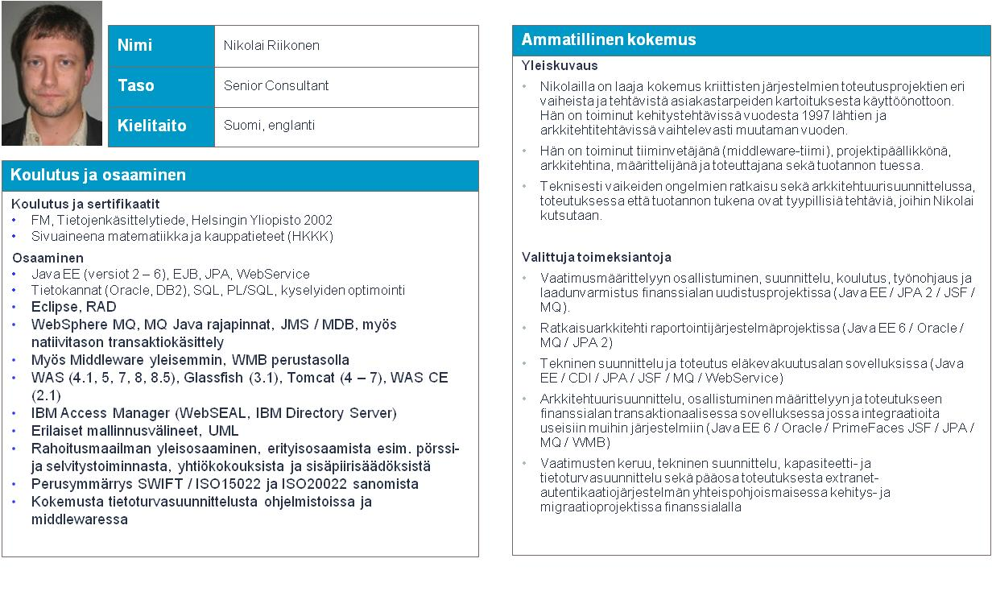

Architect

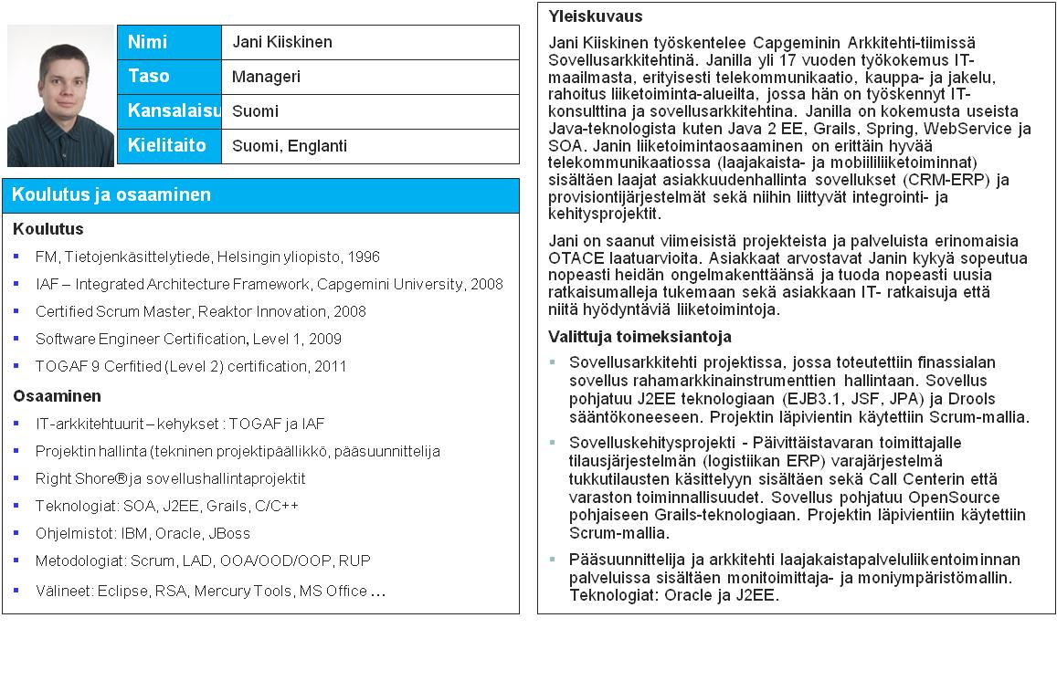

Service Delivery Manager

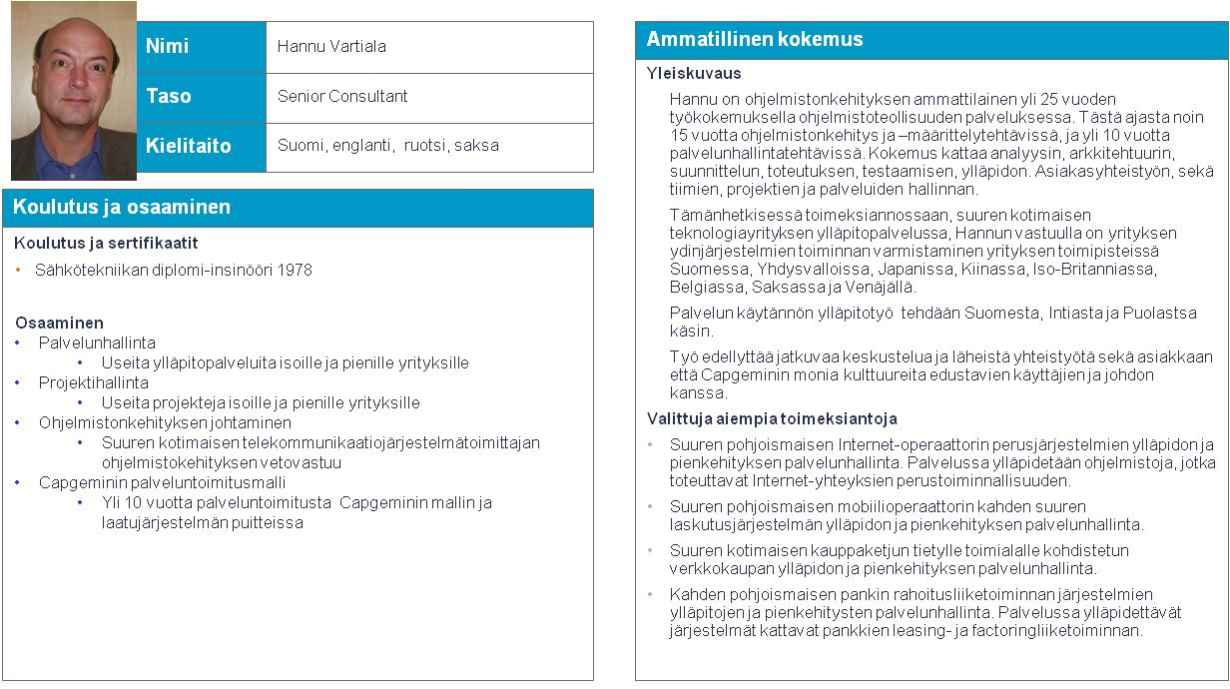

Monitoring Architect

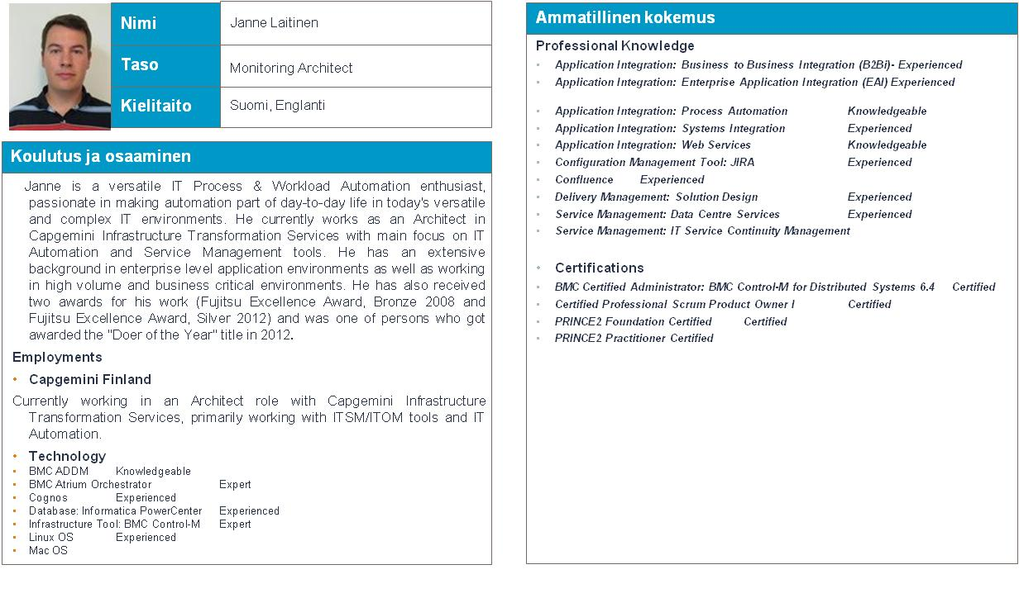

Architect



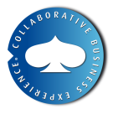About Capgemini

With almost 140,000 people in over 40 countries, Capgemini is one of the world's foremost providers of consulting, technology and outsourcing services. The Group reported 2013 global revenues of EUR 10.1 billion.

Together with its clients, Capgemini creates and delivers business and technology solutions that fit their needs and drive the results they want. A deeply multicultural organization, Capgemini has developed its own way of working, the [Collaborative Business ExperienceTM](http://www.capgemini.com/about/how-we-work/the-collaborative-business-experiencetm), and draws on [Rightshore®](http://www.capgemini.com/about/how-we-work/rightshorer), its worldwide delivery model.

Learn more about us at [www.capgemini.com](http://www.capgemini.com)

Rightshore® is a trademark belonging to Capgemini